**CASE REPORT**

***Migratory And Misleading Abscess Of Oral Cavity***

Dr Dikshita Medhi, Dr Dharitri Sharma, Dr Ellora Madan, Dr Jharna Bharali

**Abstract:**

*Acute pericoronitis usually presents with severe localized pain, swelling and sometimes trismus. However, chronic pericoronitis and periodontal abscess produce a dull pain, moderate swelling and are occasionally seen migrating into distant sites producing fistulae intra ‑ orally and/or extra ‑ orally. This may quite often cause diagnostic dilemmas hence, careful clinical examination and sometimes special investigations is needed to confirm the etiology and origin of infection. Treatment must be focused on the elimination of the source of infection; once the infection is eliminated there is a rapid resolution of the sinus tract. A 28 year old patient reported to this institution with inflamed, swollen tissue and pus discharge in the #37 region with partial trismus. He also has an unerupted #38 which is palpated upon probing. Following palliative treatment for 5 days. Extraction of #38 was done with curettage of #37 region. Uneventful healing was observed in three weeks*.

**Key Words: migratory abscess, pericoronitis**

**Introduction**

Migratory abscess infections may break down or hydrolyse the tissue barriers to invade the distant sites and form an abscess in the new site. It points both intra and extraorally at a considerable distance from the causative site. Pus from pericoronitis of a lower third molar can track forward along an anatomical gutter formed by the body of the mandible and the attachment of the buccinator as it sweeps down along the external oblique ridge to the alveolar bone in the first molar region.1

Pus tracking along this inclined gutter eventually localizes in the loose connective tissues lining the under surface of the mucosal reflection alongside the second molar. Such an accumulation of pus is commonly termed ‘migratory abscess’from a pericoronitis.1

1*.Post Graduate Student*

*Department of Periodontology*

*2. Professor and Head of Department*

*Department of Periodontology*

*3. Senior Lecturer*

*Department of Periodontology I*

***\*Correspondence Address:***

*Dr. Dikshita Medhi*

*Dept. of Periodontology*

*Kothiwal Dental College & Research Centre Moradabad*

Email: [medhid5@gmail.com](mailto:medhid5@gmail.com)

The soft tissue covering over a partially erupted tooth is known as pericoronal flap or gingival operculum. Maintenance of the oral hygiene particularly in the operculum area is very difficult to achieve by normal methods of oral hygiene. Amongst acute oral health problems of young adults, pericoronitis is found to be ranked as first or second.2,3Pericoronitis manifests itself in both acute and chronic state, the former often being characterized with periods of quiescence, which may or may not include episodic acute attacks.4

**Etiopathology of Pericoronitis**

The most common cause of pericoronal inflammation is the entrapment of plaque and food debris between tooth and overlying operculum. Hence, it is difficult to clean those areas. These areas favour the growth of bacteria. Factors which may aggravate the inflammation are trauma due to occlusion or entrapment of foreign body below the pericoronal flap like food particles.

The increase in the bulk of the pericoronal flap due to the release of inflammatory tissue fluid and cellular exudate may cause difficulty in complete closure of the jaw.4,5 A systemic condition may also lead to compromised host immune system. So, migratory abscess of pericoronitis can be considered as an opportunistic infection or may be an opportunistic exacerbation of a chronic process.

**Clinical features of migratory abscess**

1. The affected site is usually red, swollen, tender and with suppuration.
2. The pain is severe, throbbing in nature which is radiated to the ear, throat, floor of the mouth, temporomandibular joint and posterior submandibular region.
3. Swelling of the cheek in the region of the angle of the jaw along with trismus is evident.
4. Systemic complications can occur such as fever, leukocytosis, malaise, regional lymphadenopathy and loss of appetite.
5. In severe cases, infection may extend in to the adjacent tissue spaces and cause oro-facial fistula.

Depending on the severity of the inflammation, systemic complications and the direction of impaction of the involved tooth, different treatment modalities like operculectomy or extraction of involved tooth can be planned.

**Management of migratory abcess:**

Treatment must be focused on the elimination of the source of infection; once the infection is eliminated there is a prompt resolution of the sinus tract. If the source of the infection is a retained root or non restorable tooth or if the involved tooth is periodontally hopeless, extraction of the tooth is the only possible treatment.6

**Case Report**

A 28 years male patient came to the Department of Periodontology with a chief complaint of pain in the lower left back tooth region since last 10 days. The pain was throbbing in nature and was radiating to the neck and the ear. The pain caused reduced mouth opening due to which he was unable to eat and speak properly. The pain occurred one month back in the same region and got relieved on taking medication but it recurred.

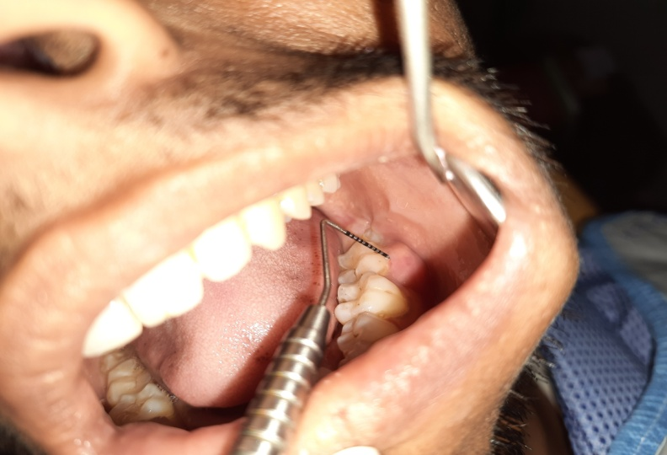

**Figure 1: Pre-operative clinical view of #37 region with a pocket of 4 mm mid-buccally**

Intra oral examination reveals periodontal pocket of 4 mm mid-buccally (figure 1), length of abscess is 12 mm (figure 2) and width is 11 mm (figure 3). Provisional diagnosis of migratory abscess of pericoronitis irt #37 region is made. Radiographic examination reveals vertically impacted tooth irt #38 (figure 4). Based upon all the examination and findings, a final diagnosis of migratory abscess irt #37 region is made.

**Treatment procedure**

The patient was advised antibiotics (Amoxicillin 500 mg + Clavulanic acid 125 mg) thrice a day, Metronidazole 400 mg along with anelgesics (Aceclofenac 100 mg + Paracetamol 325 mg) twice a day for 5 days.

After 2 days, the patient was recalled. On evaluation, reduction of the swelling was observed.

On the fifth day when the swelling, trismus and pain completely subsided in the region of #38, the area was anaesthetized with 2% lignocaine of 1:100,000 adrenaline. After the affected area was anaesthetized, transalveolar extraction was done irt #38. Curettage of #37 and #38 were done with gracey curettes. The area was irrigated with 1% povidone iodine.

The patient was recalled for follow up on 7th, 14th day and 1 month (figure – 5).

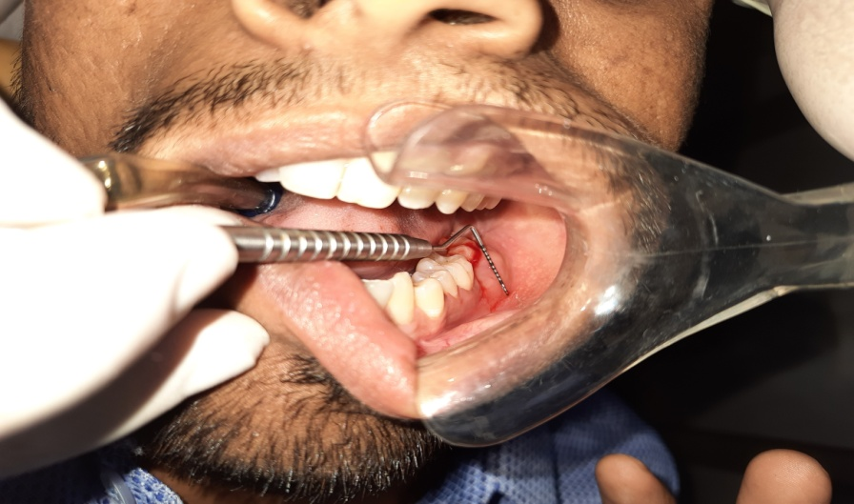

**Figure 2: Length of abscess (12mm)**

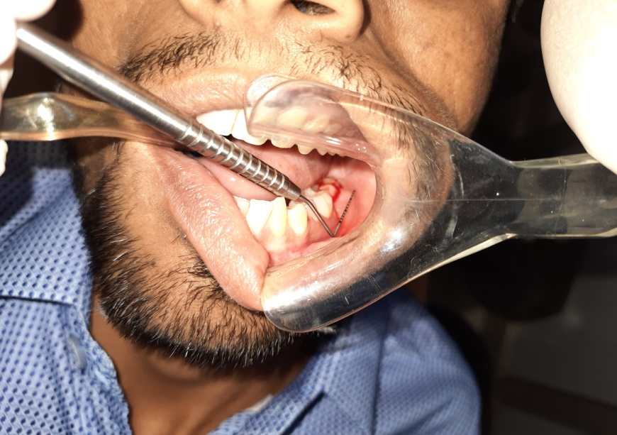

**Figure 3: width of abscess is 11mm**

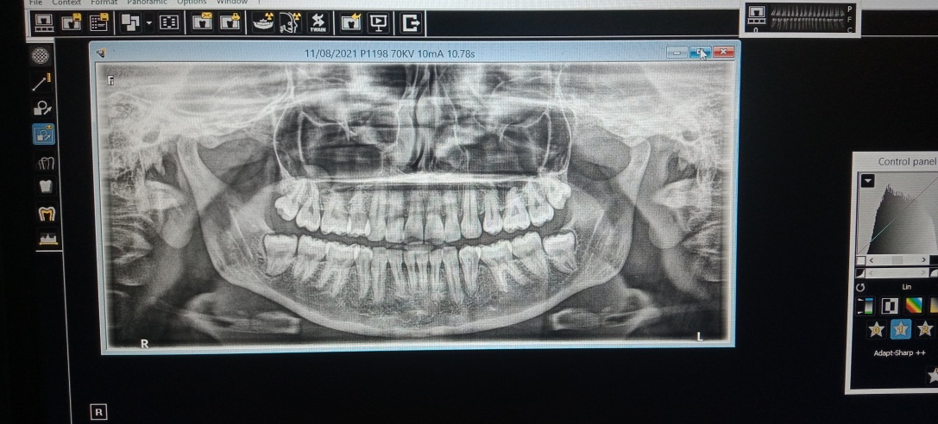

**Figure 4: vertically impacted 38**

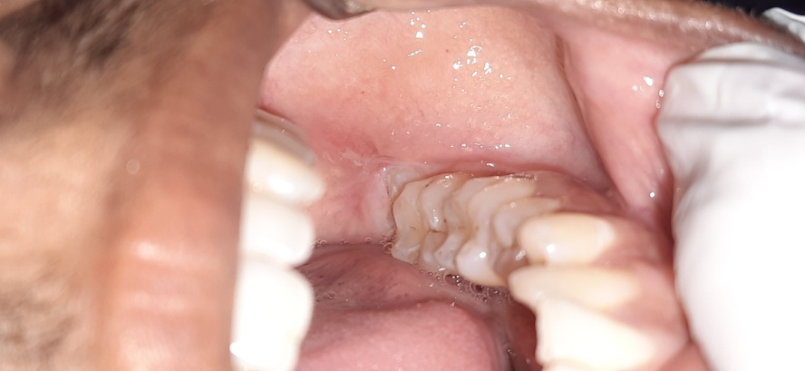

**Figure 5: follow up after 14 days**

**Discussion**

The tooth in the affected area was partially erupted and through the operculum its mesial margin was felt clinically with the help of periodontal probe. While eating, food got accumulated and the patient was not able to clean the area properly. There was throbbing pain and bleeding in the region and the patient was not able to open the mouth during speech and while eating. The pain got relieved upon medication. The tooth was non-carious and was not on proper occlusion with the opposing teeth. On radiographic examination the prognosis of #38 was poor because it was vertically impacted and extraction was suggested as the patient was also not willing to retain the tooth. Thus transalveolar extraction was suggested to the patient. Transalveolar extraction is the method which includes removal of alveolar bone to access and extract the tooth. It is generally practiced for extraction of impacted teeth, root pieces, or teeth with unfavorable root form. It is often termed as surgical extraction or complicated exodontia.7 Teeth with severely undermined crown, fractured teeth, endodontically treated teeth, teeth with unfavourable root form, ankylosed teeth, impacted tooth, tooth in proximity to vital structures and long standing tooth with grossly carious crown are the indications of transalveolar extraction. The disadvantage was excessive bleeding that took place during the procedure. In addition, patient also experienced pain post operatively for a longer period of time. The patient was recalled after 7th, 14th day and 1 month for re – evaluation.

**Limitation**

1. Excessive bleeding occurred during the procedure.
2. Post-operative pain was also experienced by the patient for a longer period of time due to transalveolar extraction.

**Conclusion**

Though pericoronitis around third molar as a disease entity looks small but one cannot neglect its potential complications. Beside its local symptoms, this small inflammation can transform into localized abscess or can spread into adjacent soft tissue spaces leading to life threatening conditions if left untreated.1 A proper diagnosis should be made on the basis of thorough case history, clinical examination and radiographic assessment. Depending on the diagnosis, most appropriate treatment plan should be implemented on an emergency basis.1

**References**

1. Ho KH. A migratory abscess pointing intra orally and extra orally. Case report. Aust Dent J. 1989 Jun;34(3):226-7.
2. Guralnick W. Third molar surgery. Br Dent J 1984;156:389-94.
3. Ludwick WE, Pogas JA, Gendron EG, Weldon AL. Dental emergencies occurring among Navy-Marine personnel serving in Vietnam. Mil Med 1974;139:121-23.
4. Moloney J, Stassen L. Pericoronitis: treatment and a clinical dilemma. J Irish Dent Assoc 2009;55(4):190-92.
5. Marucha PT. Acute gingival infections. In: Newman MG, Takei HH, Klokkevold PR, Carranza FA. Carranza’s clinical periodontology 10th Ed. WB Saunder’s Co;2006:400-1.
6. Arun Kumar KV, Deepa D. Migratory and misleading abscess of oro-facial region. J Indian Soc Periodontol. 2015 Jul-Aug;19(4):470-3.
7. Jain, Anuj. (2021). Principles and Techniques of Exodontia. 10.1007/978-981-15-1346-6_13.