**CASE REPORT**

***Congenital Epulis – A Rare Entity of the Newborn***

Dimpy Mazumdar1, Kamini Kumari1, Rajendragouda Patil2, Udita Singh3,Astha Durgvanshi4

**ABSTRACT**

*Oral lesions in neonates represents a wide range of diseases often creating apprehension and anxiety among their caregivers. A newborn with large intraoral swelling that may interfere with feeding and may carry a risk of airway obstruction can be an alarming sign for both parents and healthcare professionals. Dentists should be able to recognize these swellings as they may be asked to consult and provide information to parents and other practitioners regarding treatment of these lesions. Here we are presenting a case report of a newborn with an intraoral mass in the maxillary alveolar ridge region along-with diagnostic algorithm and an extensive review of literature.*

**Keywords:** **Neonates, Epulis, Granuloma,Congenital**

**INTRODUCTION**

Congenital oral tumors are commonly recognized at birth or just after birth except in instances where the tumor is very small and causing no obvious symptoms. Clinically, lesions of the oral mucosa are divided into surface lesions and soft tissue enlargements, which are either reactive enlargements or tumors. Tumors can be solid or cystic, benign or malignant, and congenital or non congenital.

Congenital epulis is an extremely rare intraoral tumor of the newborn. Also known as Congenital Gingival Granular Cell Tumour, it is a rare benign hamartoma of the alveolar ridge found in the newborn.The German pathologist Dr. Franz Ernst Christian Neumann was credited for first describing this lesion as “Congenital epulis” in 1871. Epulis is a word derived from the ancient Greek language and translates into “swelling on the gingiva”.1 In medical literature, this lesion is known by many names such as Neumann tumor, Abrikosov tumor, granular cell myoblastoma, and so on; however, the recommended terminology by the World Health Organization is “congenital granular cell epulis”.2 It usually presents at birth with an obvious mass arising from the anterior part of the maxillary alveolar ridge and can also occur in the mandible or in the tongue.

1. *Post Graduate student*
2. *Professor and H.O.D*
3. *Reader*
4. *Professor*

*Department of Oral Medicine and Radiology*

***Correspondence Address***

*Dr Kamini Kumari*

*Department of Oral Medicine and Radiology.*

*Kothiwal Dental College and Research Centre, Moradabad*

*Email: kaminikk25@gmail.com*

There is a marked female preponderance of 8:1 with a Caucasian predisposition. Clinical manifestations depend on the size and location of the lesions and include respiratory insufficiency, difficulty in sucking and swallowing and/or inadequate closure of mouth.3

Multiple lesions are rare, occurring in only 10% of all reported cases. The size of the mass varies from a few millimetresupto 9 cm in diameter.4 Clinically, this lesion presents itself in the form of a broad-based, firmly attached solitary-like polypoid nodule with a predominant labial aspect of the gingiva.6 Because of the size of the tumor and risk of interference with the newborn feeding and respiration, the treatment of choice is often acute surgical excision under local or general anaesthesia, although spontaneous regression has also been reported. There are no reports of recurrence, even if incomplete margins are excised, malignant change, or future disruption to teeth or gums.7 Epulis is seen only in the newborn and is thought to be a different entity from other adult granular cell tumors.8The diagnosis is usually clinical, although difficulties may occur when the index of suspicion is low or when the origin of the tumor is hard to determine. Here we are reporting a case of 2 weeks newborn which was not diagnosed at other centres and left the parents anxious.

**CASE REPORT**

A 2 weeks old female newborn along with her parents reported to the department of Oral Medicine and Radiology, Kothiwal Dental College and Research Centre, Moradabad for evaluation and possible treatment of a mass protruding from her mouth. The infant was born on the 36th week of gestation by a vaginal delivery. Mother was 28 years of age, apparently healthy with no significant drug history or family history. Pregnancy and parturition were normal. Ultrasound scans performed at the 25th week of gestation did not reveal any abnormality. The birth weight of newborn was 2.7kgs. At birth, parents noticed a firm, oval shaped mass protruding from the mouth of the infant. The mass was not associated with any ulceration, drainage or alteration in size. On clinical examination, a single, well defined oval shaped, sessile mass arising from the left upper alveolar margin with a broad base was seen. The lesion was non tender, firm, smooth and measured approximately 3cm × 2cm extending below the occlusal plane and thus interfering with normal closure of the mouth and breastfeeding. The surrounding palatal and alveolar mucosa was normal. The mass posed no immediate airway concerns and no other pathologic finding was noted.

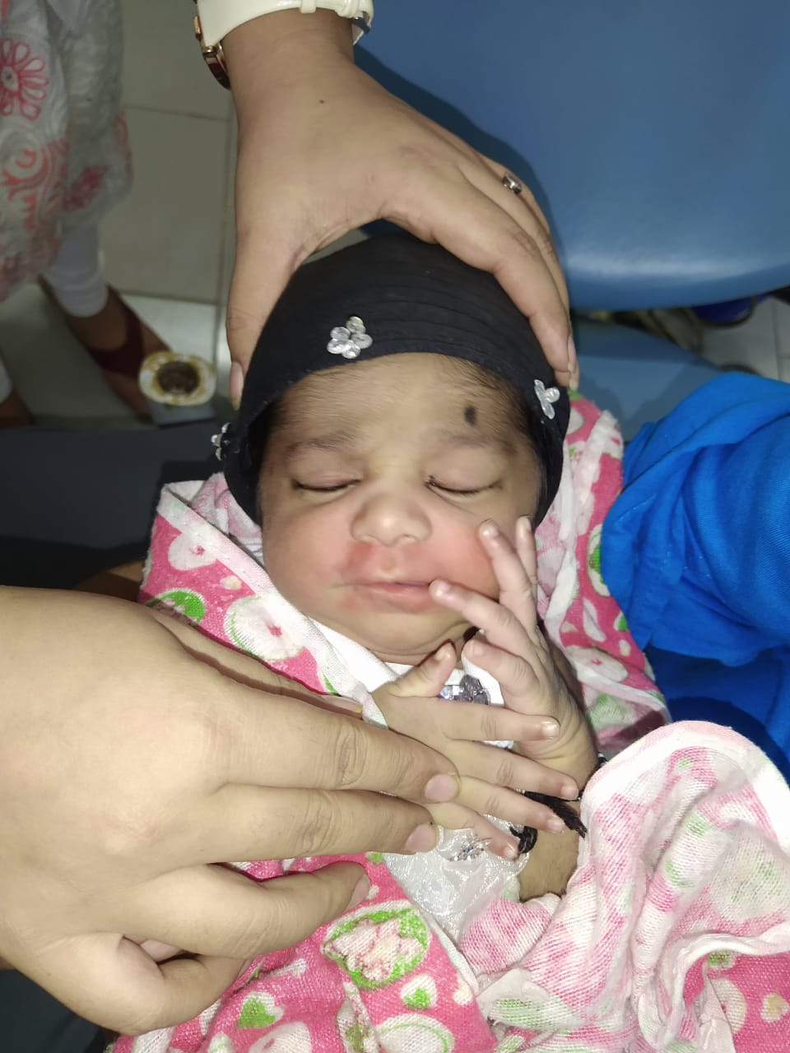

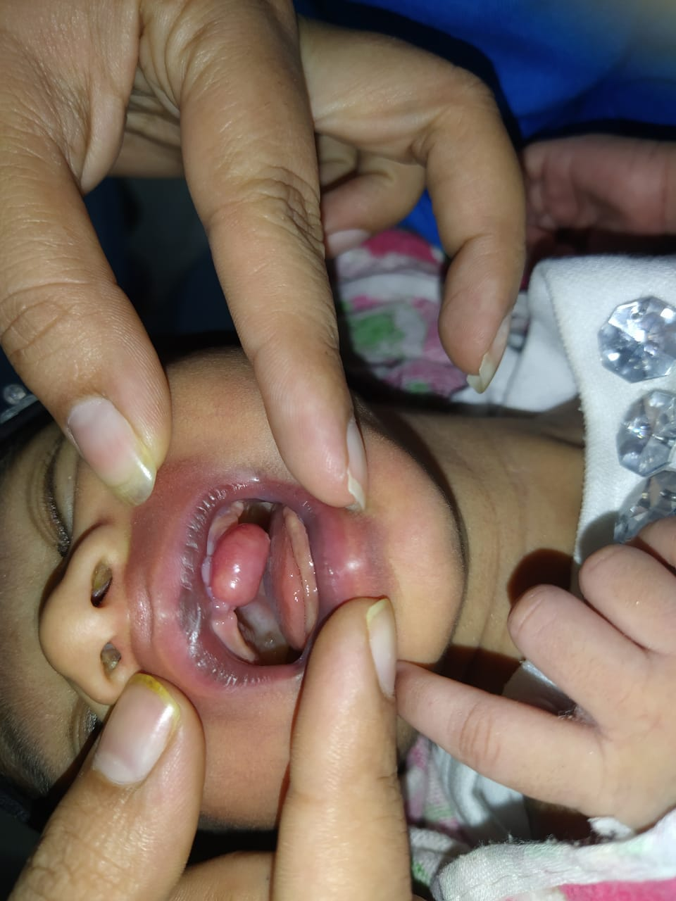

Considering the history and clinical findings, a provisional diagnosis of Congenital epulis was made. The differential diagnosis were given as Fibroma though there was no history of trauma reported and Hemangioma but diascopy test was negative and colour of the mass was not in favour. As the child was only 2 weeks old, we have avoided the radiation exposure as this radiation may pose certain risks. Considering the tender age of the patient, complete surgical excision was planned under general anesthesia after 2 months and the excised mass to be sent for histopathological examination.

**DISCUSSION**

Congenital epulis may or may not be associated with other congenital anomalies.9,10 In general, it occurs as solitary lesion but multiple lesions may also occur in up to 10% of cases.10,2 Occurrence is sporadic and no familial tendencies have been described.10,2 The etiology is unknown and there is still controversy regarding exact cell of origin.11 An undifferentiated mesenchymal cell origin, fibroblastic and myoblastic, histiocytic, odontogenic, neurogenic, endothelial and endocrinologic etiologies had been proposed but most of the reported cases support a mesenchymal origin.2

Prenatal imaging by ultrasonography or magnetic resonance imaging  (MRI) is possible but not certain.2 Postnatally computed tomography or MRI of the head is useful in demonstrating the extent and differential diagnosis of congenital maxillofacial mass lesions and for planning surgical treatment.1

CGCE growth patterns show a significant tumor enlargement during the third trimester of the pregnancy and a sudden stop of growth after birth. Owing to this fact and the correlation to female newborn predominance, it is believed that maternal hormones stimulate tumor growth. However numerous reports have shown no evidence of either oestrogen or progesterone receptors, and as such suggest an alternative histogenesis.12

Spontaneous involution after birth is rare but reported in literature and therefore conservative treatment is sometimes sufficient.2,13,14 When the lesion is obstructing feeding or respiration, surgical removal is indicated. Conservative surgical excision at the tumor base should be done to allay the parent agitation. Wide radical excision is not recommended. There are no reports of local recurrence after incomplete excision. There are also reports of conservative surgical removal with CO2 laser.15

**CONCLUSION**

Newborns with a diagnosis of congenital epulis should be immediately subjected to the simple conservative surgical excision to restore vital functions and improve quality‑of‑life. Although this lesion is rare, but every practitioner should be aware of this so that they can tell the parents and caregivers that despite its dangerous look, it is easy to treat this lesion without any further complications. The family of an infant with congenital epulis should be assured of the benign nature and the simple treatment of the condition.

**REFERENCES**

1. Guven S, Kaymakci A, Bugday MS, Yilmaz M. Congenital granular cell tumor. J Craniofac Surg 2009;20(3):976e7.
2. Wall VD. World Health Organization classification of tumours. In: Barnes L, Eveson JW, Reichart P, Sidransky D, editors. Pathology and genetics. Head and neck tumours. Lyon: IARC Press; 2005. p. 198.
3. Küpers AM, Andriessen P, van Kempen MJ, van der Tol IG, Baart JA, Dumans AG, et al. Congenital epulis of the jaw: A series of five cases and review of literature. Pediatr Surg Int 2009;25:207‑10.
4. S. Kanotra, S. P. Kanotra, and J. Paul, “Congenital epulis,” Journal of Laryngology and Otology, vol. 120, no. 2, pp. 148– 150, 2006.
5. Fister  P, Volavsek  M, Novosel Sever  M, Jazbec  J. A  newborn baby with a tumor protruding from the mouth. Diagnosis: Congenital gingival granular cell tumor. Acta Dermatovenerol Alp PanonicaAdriat2007;16:128‑30.
6. Conrad R, Perez MC. Congenital granular cell epulis. Arch Pathol Lab Med 2014;138(1):128e31.
7. Zerener T, Sencimen M, Altun C, Altug HA. Congenital granular cell tumor in newborn. Eur J Dent 2013;7(4):497e9
8. Lapid  O, Shaco‑Levy  R, Krieger  Y, Kachko  L, Sagi  A. Congenital epulis. Pediatrics 2001;107:E22.
9. Lapid  O, Shaco‑Levy  R, Krieger  Y, Kachko  L, Sagi  A. Congenital epulis. Pediatrics 2001;107:E22.
10. Godra A, D’Cruz CA, Labat MF, Isaacson G. Pathologic quiz case: A newborn with a midline buccal mucosa mass. Congenital gingival granular cell tumor  (congenital epulis). Arch Pathol Lab Med 2004;128:585‑6.
11. Lack  EE, Worsham  GF, Callihan  MD, Crawford  BE, Vawter  GF. Gingival granula cell tumors of the newborn  (congenital “epulis”): A  clinical and pathologic study of 21  patients. Am J Surg Pathol1981;5:37‑46.
12. P. Leocata, G. Bifaretti, S. Saltarelli, A. Corbacelli, and L. Ventura, “Congenital (granular cell) epulis of the newborn: a case report with immunohistochemical study on the histogenesis,” Annals of Saudi Medicine, vol. 19, no. 6, pp. 527–529, 1999.
13. Witman PM, Rogers RS 3rd. Pediatric oral medicine. Dermatol Clin 2003;21:157‑70.
14. Merrett SJ, Crawford PJ. Congenital epulis of the newborn: A case report. Int J Paediatr Dent 2003;13:127‑9.
15. Dash  JK, Sahoo  PK, Das  SN. Congenital granular cell lesion “congenital epulis” – Report of a case. J Indian Soc PedodPrev Dent 2004;22:63‑7