**Case Report**

***Hemisection-a window of hope for a perishing tooth***

Jharna Bharali1, K.K.Chaubey2, Vishal Kumar1,Vaishali1

**Abstract:**

*Hemisection is a removal of compromised root and the associated crown portion. It is one of the treatment options for preserving remaining part of molar having sound periodontium. Present case report demonstrates the hemisection of #36 so as to preserve the tooth structure, alveolar bone and cost savings (time and money) over other treatment options and further opt for fixed partial prosthesis to retain the tooth.*

**Key Words:** Furcation involvement, Hemisection, Root resection, Fixed partial denture.

**Introduction**

Loss of the posterior teeth is eventful and undesirable often leading to teeth drifting, loss of masticatory function and loss of arch length, which requires prevention and maintenance measures.1 Management of periodontally involved molars with extensive decay is a challenging and is limited to dental extraction and replacement with implants. Treatment strategy to retain such teeth involves periodontal, prosthodontic and endodontic assessment for appropriate selection to allow for stronger survival.2The term tooth resection denotes the excision and removal of any segment of the tooth or a root with or without its accompanying crown portion. Various resection procedures described are: root amputation, hemisection, radisection and bisection.3 Hemisection denotes removal or separation of root with its accompanying crown portion of mandibular molars.1,

**Endodontic and Restorative Indications**

*Prosthetic failure of abutments within a splint*: If a single or multi-rooted tooth is periodontally involved within a fixed bridge, instead of removing the entire bridge, if the remaining abutment support 3Hemisection is a conservative way of preserving tooth. It is a treatment modality, which allows the preservation of tooth structure, alveolar bone and cost savings over other treatment options.2 Weine F has listed the following indications for tooth resection:4

1. is sufficient, the root of the involved tooth is extracted.
2. *Endodontic failure:* Hemisection is useful in cases in which there is perforation through the floor of the pulp chamber, or pulp canal of one of the roots of an endodontically involved tooth which cannot be instrumented.

*1.Post Graduate Student*

*Department of Periodontics*

*2. Professor and HOD*

*Department of Periodontics*

***\*Correspondence Address:***

*Dr. Jharna Bharali*

*Dept. of Periodontology*

*Kothiwal Dental College & Research Centre Moradabad*

*Email: jharna07pisces@gmail.com*

1. *Vertical fracture of one root*: The prognosis of vertical fracture is hopeless. If vertical fracture traverses one root while the other roots are unaffected, the offending root may be amputed. 4. Severe destructive process: This may occur as a result of furcation or sub gingival caries, traumatic injury, and large root perforation during endodontic therapymay be exacerbated by various factors.7

**Periodontal Indications**

1. Severe vertical bone loss involving only one root of multi-rooted teeth.
2. Through and through furcation destruction.
3. Unfavourable proximity of roots of adjacent teeth, preventing adequate hygiene maintenance in proximal areas.
4. Severe root exposure due to dehiscence

Hemisection represents a form of conservative dentistry, aiming to retain as much of the original tooth structure as possible.2,4 Hemisection (removal of one root) involves removing significantly compromised root structure and the associated coronal structure through deliberate excision.5

**Indications for Hemisection6**

1. The tooth is affected by caries, vertical root fracture, periodontal disease or iatrogenic root perforation where only one root of a multi-rooted tooth is affected.
2. The surviving root is accessible and treatable endodontically.
3. The surviving root is structurally capable of supporting a dowel and core restoration.
4. The surviving root is aligned so as to provide proper draw for the resulting fixed prosthetic restoration.
5. The root morphology allows for surgical access and proper periodontal maintenance of the final restoration.4-9

**Contraindications for Hemisection6**

1. Poorly shaped roots or fused roots.

2. Poor endodontic candidates or inoperable endodontic roots.

3. Patient unwilling to undergo surgical and endodontic treatments and undertake the care or the resulting restoration.6-8

**Case Report**

A 20 years of female patient came to the Department of Periodontology in Kothiwal Dental College & Research Centre with a chief complaint of pain in the lower left back tooth region since last 1 year and wants to restore it. She also complained of accumulation of food in the area and difficulty in eating [Fig 1].

.

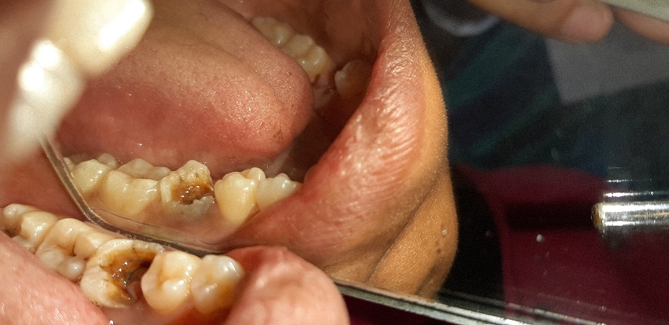

**Figure 1:Pre-operative clinical view of#36**

On taking a proper history, patient reported that root canal treatment (RCT) was done in the same tooth 2 years back and oral prophylaxis was done 8 months back. The patient did not have any medical history. Patient was asymptomatic 1 year back when she developed pain in the same tooth.

The pain was not associated with fever. On clinical examination, the left mandibular first molar was sensitive to percussion. On probing the tooth, the restoration of the mesiolingual portion of the crown was broken and the tooth was exposed. There was periodontal pocket of around 5 mm in the mesial aspect of the same tooth from the buccal side. On radiographic examination; there was a fracture on the mesial root of #36 approaching from the furcation area (Figure 2). Bone loss was evident at the furcation area and on the mesial aspect of #46. The bony support of distal root was intact.

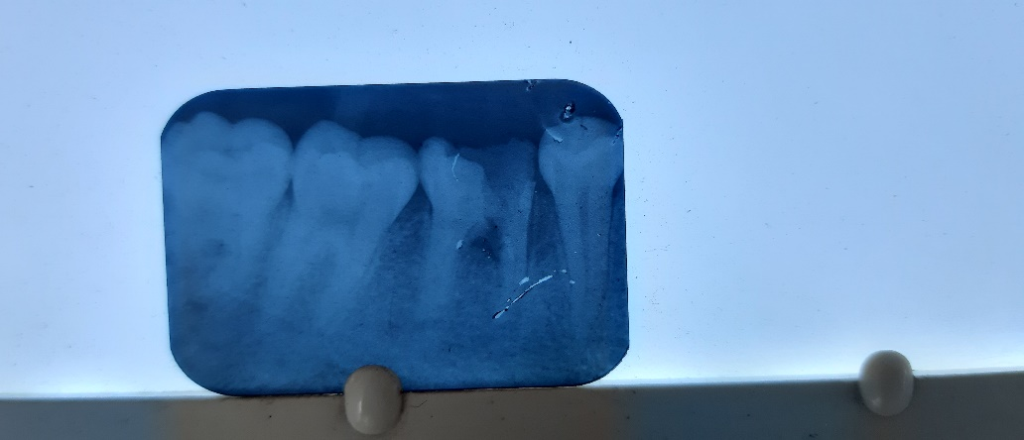

**Figure 2: Pre-operative radiographic view of #36.**

**Treatment procedure**

After thorough scaling and root planing, re-RCT was done irt distal root of #36 [Fig 3 (a) and (b)]. The patient was advised antibiotics (Amoxicillin 500 mg + Clavulanic acid 125 mg) thrice a day, along with anelgesics (Aceclofenac 100 mg + Paracetamol 325 mg) twice a day for 5 days. On the 3rd day, after the area was anaesthesized with 2% lignocaine (1:100,000) adrenaline, a crevicular incision was given from the distal aspect of #35 to the mesial aspect of #36 [Fig 3 (c)].Then the flap was reflected with the help of a periosteal elevator [Fig 3 (d)].

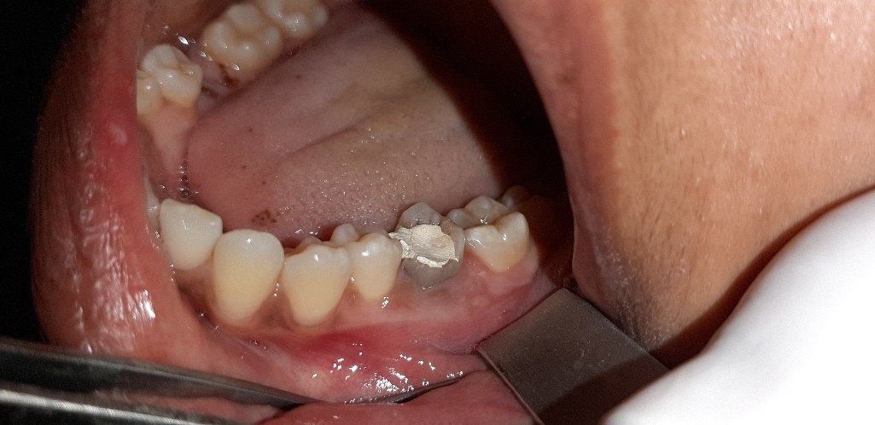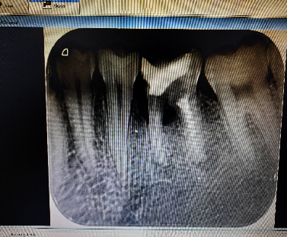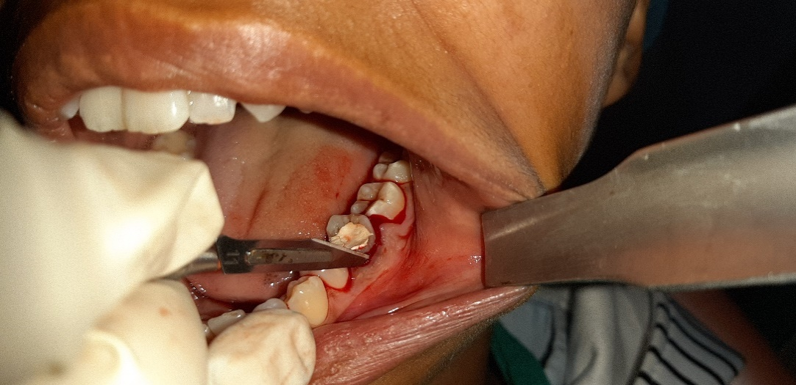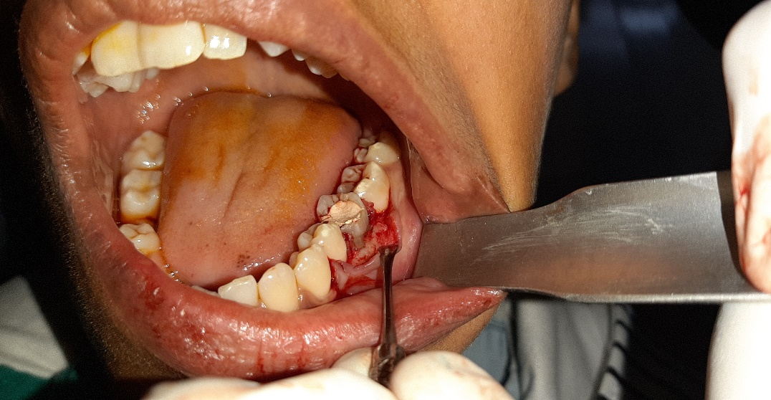

**Figure 3: (a) Re-RCT was done irt distal root of #36 (clinical view) (b)Radiographic view (c)Crevicular incision was given (d) Flap was reflected with the help of a periosteal.**

The tooth was then divided into two halves (mesial and distal portion) with the help of a straight bone cutting bur [Figure 4 (a)]. After that the mesial root was extracted and alloplastic bone graft was placed in the area [Figure 4(b)]. 4-0 silk sutures were used to suture back the flap reflected [Figure 4 (c)]. The exposed portion of the crown was restored with a temporary restoration and then periodontal dressing was placed over the area [Figure 4 (d)].

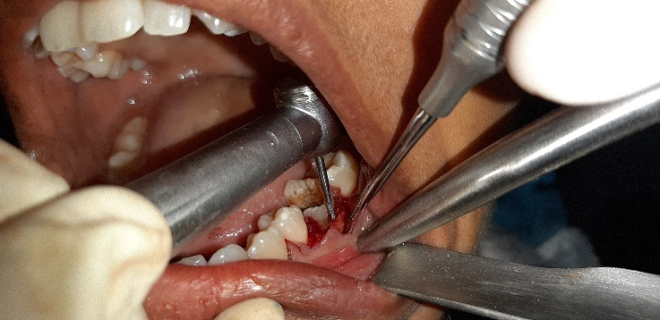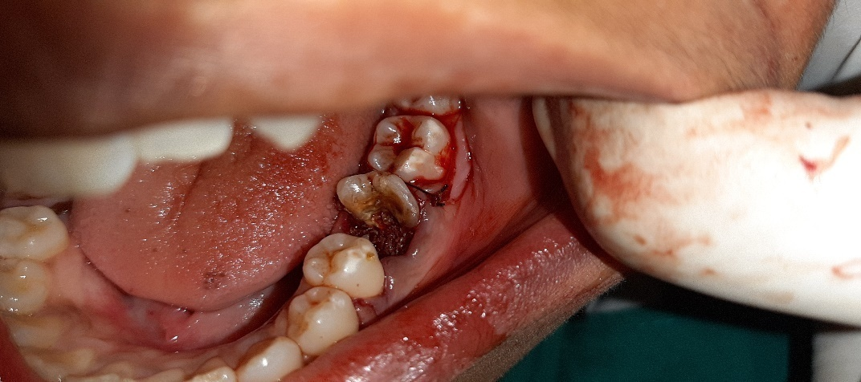

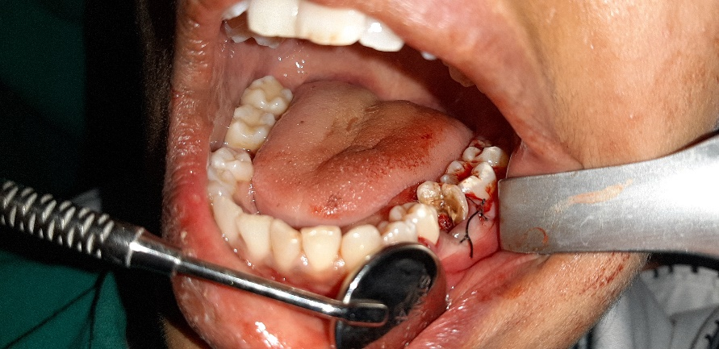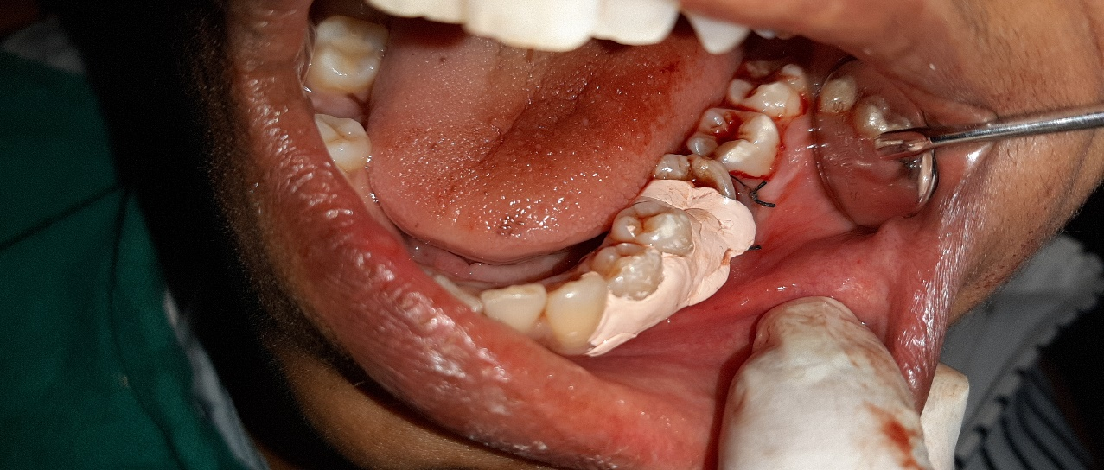

**Figure 4: (a)The tooth was divided with a bone cutting bur (b) the mesial portion of the tooth was removed and alloplastic bone graft was placed (c) 4-0 silk sutures were placed (d) periodontal dressing was placed.**

The patient was recalled after 15 days for suture removal as well as to take an IOPAR irt #37 (post-operative) (Figure 5).After that the patient was referred to the department of Endodontics for the further treatment procedures.

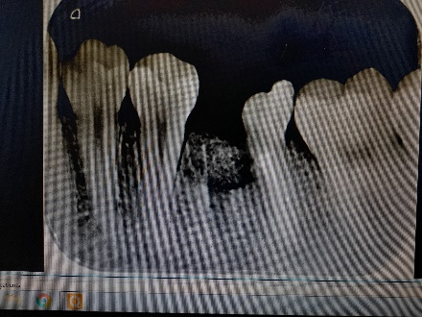

**Figure 5: Post-operative radiographic view of #37 after 15 days**

**Discussion**

Hemisection dental surgery is a procedure in which a tooth with multiple roots is sectioned in halves.7 This procedure may be needed when there is bone loss, or dental decay between the roots due to gum (periodontal) disease.7,8Multirooted, periodontally involved molars can be maintained for long periods of time with hemisection depending on their extent of bone destruction justifying that periodontal surgical therapy is required in cases where advanced periodontal bone loss has occurred and is less likely to resolve after nonsurgical therapy alone.9 The success of the root resection procedure depends to a large extent on proper case selection.1,2,7,9 The hemisection is a useful alternative treatment to extraction to save the multirooted tooth with periodontal, endodontic, restorative, or prosthetic problems.3,10 The literature on the distal root resection in mandibular is limited as compared to mesial root because of its anatomical structure. In the present case, the case selection criteria for performing a hemisection was optimum as the roots were not closely approximated or fused.11,12,13,14 Re-RCT of the distal root of #37 was performed before the procedure to overcome the periapical infection.14Root fracture was the main cause for performing Hemisection as the patient wanted to preserve the natural tooth. Bhuler13 (1988) observed 32% failure rate in hemisection case due to endodontic pathology and root fracture while long-term studies have shown greater success.Thus, the hemisection can be considered as an effective and conservative treatment against extraction of the tooth with extensive caries.12,14

**Clinical Significance**

This treatment can produce predictable results as long as proper case selection is followed by interdisciplinary approach with endodontic, surgical, and prosthetic procedures and is a viable alternative, conservative in approach, while maintaining form and function, as opposed to extraction procedures.

**Conclusion**

Therapeutic planning, operative sequence, and pluridisciplinarity exerted in this case illustrate the importance of specialized knowledge and professional communication. Hemisection is a baton for the extracting teeth. Careful case selection determines the long term success of the procedure.

**References**

1. Akki S, Mahoorkar S. Tooth hemisection and restoration an alternative to extraction - A case report. Int J Dent Clin 2011;3:67-8.
2. Yuh DY, Lin FG, Fang WH, Chien WC, Chung CH, Mau LP, et al. The impact of medical institutions on the treatment decisions and outcome of root-resected molars: A retrospective claims analysis from a representative database. J Med Sci. 2014;34:1–8.
3. Carnevale G, Di Febo G, Tonelli MP, Marin C, Fuzzi M. A retrospective analysis of the periodontal-prosthetic treatment of molars with interradicular lesions. Int J Periodontics Restorative Dent. 1991;11:189–205.
4. DeSanctis M, Murphy KG. The role of resective periodontal surgery in the treatment of furcation defects. Periodontol. 2000;2000(22):154–68.
5. McGuire MK, Nunn ME. Prognosis versus actual outcome. III. The effectiveness of clinical parameters in accurately predicting tooth survival. J Periodontol. 1996;67:666, 74.
6. Dannewitz B, Krieger JK, Hüsing J, Eickholz P. Loss of molars in periodontally treated patients: A retrospective analysis five years or more after active periodontal treatment. J Clin Periodontol. 2006;33:53–61.
7. Langer B, Stein SD, Wagenberg B. An evaluation of root resections. A ten-year study. J Periodontol. 1981;52:719–22.
8. Basten CH, Ammons WF, Jr, Persson R. Long-term evaluation of root-resected molars: A retrospective study. Int J Periodontics Restorative Dent. 1996;16:206–19.
9. Hamp SE, Nyman S, Lindhe J. Periodontal treatment of multirooted teeth. Results after 5 years. J Clin Periodontol. 1975;2:126–35.
10. Erpenstein H. A 3-year study of hemisectioned molars. J Clin Periodontol. 1983;10:1–10.
11. Bühler H. Evaluation of root-resected teeth. Results after 10 years. J Periodontol. 1988;59:805–10.
12. Fugazzotto PA. A comparison of the success of root resected molars and molar position implants in function in a private practice: Results of up to 15-plus years. J Periodontol. 2001;72:1113–23.
13. Bühler H. Survival rates of hemisected teeth: An attempt to compare them with survival rates of alloplastic implants. Int J Periodontics Restorative Dent. 1994;14:536–43.
14. Zafiropoulos GG, Hoffmann O, Kasaj A, Willershausen B, Deli G, Tatakis DN. Mandibular molar root resection versus implant therapy: A retrospective nonrandomized study. J Oral Implantol. 2009;35:52–62.