**CASE REPORT**

***Electrocautery: a boon for operculectomy in a soft tissue impacted third molar***

Jharna Bharali1, Swati Agarwal2, Prateek Singh3,Kabyik Goldar1

**Abstract:**

*Pericoronitis is the inflammation of the soft tissue associated with the crown of a partially erupted tooth. Partially impacted teeth often present with pericoronitis leading to dilemma in diagnosis and treatment options, as to whether to extract or carry out operculectomy (and retain the tooth). However operculectomy would be preferred over extraction owing to its conservative approach. Different surgical procedures are there to remove the operculum among which the electrocautery (thermal cautery) is more suitable in selected conditions. A 45 year old patient reported to this institution with partially erupted tooth (#38) having inflammed, swollen pericoronal tissuewith partial trismus. Following palliative treatment for 5 days. Operculectomy was performed with electrocautery. Uneventful healing was observed in three weeks.*

**Key Words:Pericoronitis, operculitis, operculectomy, electrocautery.**

**Introduction**

Pericoronitis refers to inflammation of the soft tissue in relation to the crown of an incompletely erupted tooth, including the gingiva and the dental follicle. The word pericoronitis is derived from the Greek word, *peri* means "around", Latin word, *corona* means "crown" and *itis* means "inflammation." It is also known as operculitis.1 Pericoronitis of the mandibular permanent third molar is typical2, 3,but it can occur around the base of any tooth that has not erupted completely.

.

Pericoronitis is mostly involved in 67% of vertical impacted cases, 12% of mesio-angular cases, 14% of disto-angular cases and 7% of various other positions.Bilateral pericoronitis is a rare condition. It may be suggestive of underlying infectious mononucleosis.1

The soft tissue covering over a partially erupted tooth is known as pericoronal flap or gingival operculum. Maintenance of the oral hygiene particularly in the operculum area is very difficult to achieve by normal methods of oral hygiene.

*1.Post Graduate Student*

*Department of Periodontics*

*2. Reader*

*Department of Periodontics*

*3. Senior Lecturer*

*Department of Periodontics*

***\*Correspondence Address:***

*Dr.JharnaBharali*

*Dept. of Periodontology*

Kothiwal Dental College & Research Centre Moradabad

Email: [aparna.srivastava57@gmail.com](mailto:aparna.srivastava57@gmail.com)

Amongst acute oral health problems of young adults, pericoronitis is found to be ranked as first or second.4, 5 The patient suffering from pericoronitis, even with no clinical signs or symptoms, often has the gingival flap chronically inflammed and infected and has varying degrees of ulceration along its inner surface

Pericoronitis manifests itself in both acute and chronic state, the former often being characterized with periods of quiescence, which may or may not include episodic acute attacks.6 The acute condition may be exacerbated by various factors.7

**Etiopathology of Pericoronitis**

The most common cause behind pericoronal inflammation is the entrapment of plaque and food debris between crown of tooth and overlying gingival flap or operculum. Hence it is the ideal area for the growth of bacteria, moreover, it is difficult to clean.Constant chances of acute inflammation of pericoronal sites may be due to aggravating factors such as trauma, occlusion or entrapment of foreign body below the pericoronal flap (eg: popcorn husks, nut fragments).

The increase in the bulk of the pericoronal flap due to the release of inflammatory tissue fluid and cellular exudate may cause difficulty in complete closure of the jaw.7, 8 A systemic conditions such as influenza, upper respiratory tract infections or a period of stress may lead to compromised host immune system. So, acute pericoronitis can be considered as an opportunistic infection or may be an opportunistic exacerbation of a chronic process which is normally kept in check by a competent immune system. Hence it is associated with varying clinical features.

**Clinical Features of Pericoronitis**

1. In acute conditions, the operculum is usually red, swollen, tender and with suppuration.
2. The pain is severe throbbing in nature which is radiated to the ear, throat, floor of the mouth, temporomandibular joint and posterior submandibular region.
3. The food impaction in the affected area can lead to periodontal pain and pulpitis (secondary to dental caries)
4. Dysphagia along with halitosis due to poor oral hygiene.
5. Swelling of the cheek in the region of the angle of the jaw along with trismus is evident.
6. Signs of trauma like the indentations of the opposing teeth along with ulcerations can be seen.
7. Systemic complications can occur such as fever, leukocytosis (increase in number of W.B.C.), malaise, regional lymphadenopathy and loss of appetite.
8. In severe cases, infection may extend in to the adjacent tissue spaces.

Depending on the severity of the inflammation, systemic complications and the advisability of retaining the involved tooth, different treatment modalities of operculectomy can be planned.

**Operculectomy**

It is the procedure by which the affected soft tissue covering and surrounding an unerupted or partially erupted tooth is surgically removed. This procedure helps in preventing plaque buildup along with reduction of inflammation in that area. It becomes easy for the patient to maintain the oral hygiene.Operculectomy accounted for about 65.4% and was carried out more on females than males.9

There are various procedures for operculectomy, like excision of operculum with laser, scalpel, electrocautery etc. Persistent symptom-free pericoronal flaps should also be removed as a preventive measure against subsequent acute involvement.

**Case Report**

A 45 years of male patient came to the Department of Periodontology in Kothiwal Dental College & Research Centre with a chief complaint of pain in the lower left back tooth region since last 3 days. The pain was throbbing in nature and was radiating to the neck and the ear. The pain caused reduced mouth opening due to which he was unable to eat and speak properly. The pain occurred three months back in the same region and usually got reduced on taking medication but it recurred.

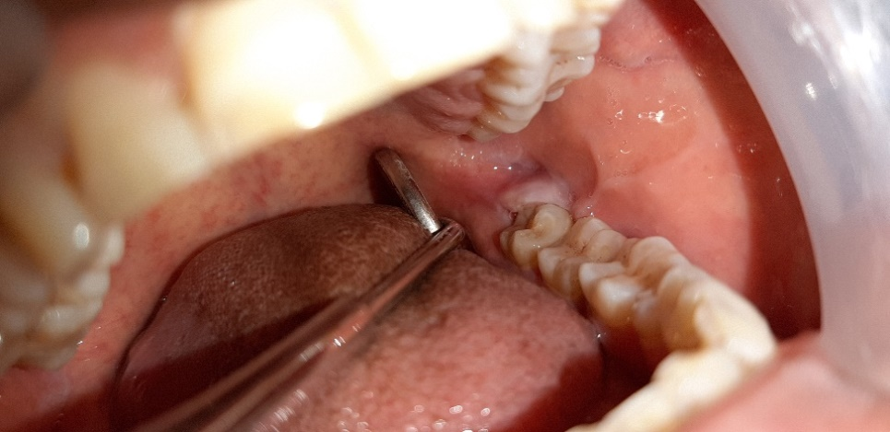

**Figure 1: Pre-operative clinical view of #38 region**

**Treatment procedure**

Thepatient was advised antibiotics (Amoxicillin 500mg + Clavulanic acid 125mg) thrice a day, Metronidazole 400 mg along with anelgesics(Aceclofenac 100mg + Paracetamol 325mg) twice a day for 5 days.

After 2 days, the patient was recalled for evaluation and reduction of the swelling was observed.

On the fifth day when the swelling, trismus and pain were completely over, the area (# 38 region) was anaesthetized with 2% lignocaine of 1:100,000 adrenaline. After the affected area was anaesthetized, the operculum to be excised was assessed with the help of a periodontal probe. It was then excised with the help of the electrocautery {ART Electrosurge}in the “cut” mode with an intensity of 7 (figure 2 & 3)

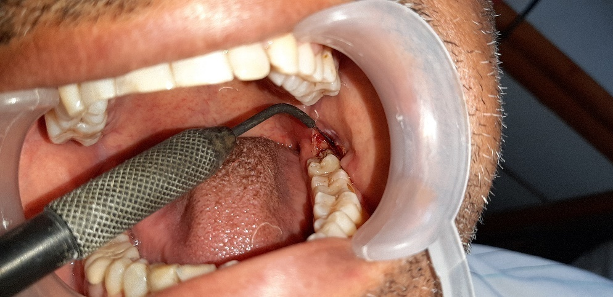

**Figure 2: The operculum was removed with the help of the electrocautery**

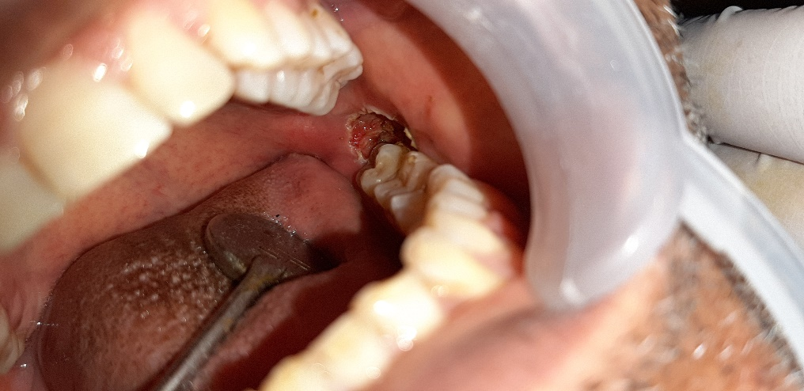

**Figure 3: The site after the removal of the operculum**

After the operculum was removed the area was properly checked for any other etiology for the occurrence of it. The distobuccal cusp of #38 was sharp which may cause irritation and might be an additional factor for the recurrence. Hence coronoplasty was done to remove the sharp cusp. The area was thoroughly irrigated with 5% betadine in conc form. Then a cotton roll covered with zinc-oxide eugenol (ZoE) was placed in the area for the soothing effect. (Figure 4)

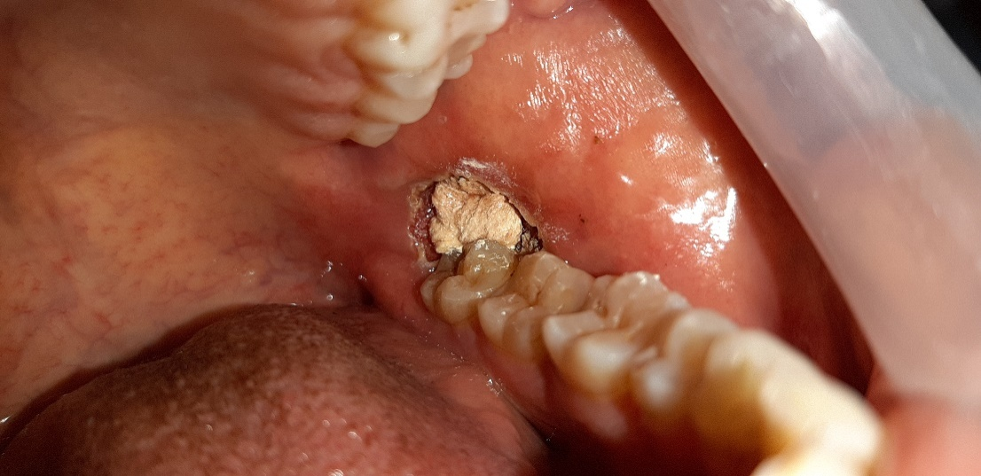

**Figure 4: ZoE was placed over the area**

The patient was called after 3 days for the dressing over the area. The patient was recalled for follow up on 7th, 14th and 1 month. (figure 5)

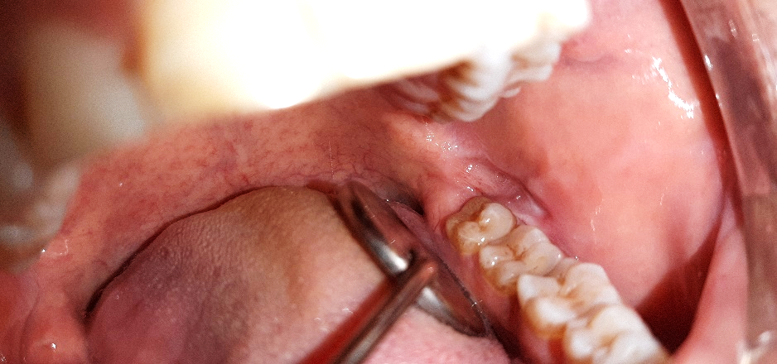

**Figure 5: Post-operative clinical view after 14 days**

**Discussion**

The electrocautery was invented by William T Bovie in 1926.10Theelectrocautery has been used in various minor surgical procedures in different fields like dermatology, ophthalmology, otolaryngology, plastic surgery and urology. In dentistry as well it is used in the excision or removal of different fibroma or abnormal growth.1,10

The tooth in the affected area was partially erupted and through the operculum its distal margin was felt clinically. While eating, food got accumulated and the patient was not able to clean the area properly. There was bleeding in the region and the patient was not able to open the mouth properly during speech and eating when he reported. The tooth was non carious and on a proper occlusion with the opposing teeth. There was adequate attached gingiva present distal to #38. The prognosis of #38 was good and extraction was not suggested. The patient was also willing to retain the natural tooth and was seeking for the alternative treatment of extraction. Hence the operculectomy procedure was selected. Operculectomy can be done by scalpel, laser or electrocautery. The only disadvantage with scalpel is the excessive bleeding that takes place during the procedure.9 Also the procedure was not done with laser because it is a time taking procedure. Hence, the procedure planned was done with the help of electrocautery as it takes less time and also less bleeding occurs at the surgical site. The healing in the area took around 20 days (delayed healing) which is one of the disadvantage of treatment with the electrocauterys.

**Limitation**

1. Post-operative pain is experienced by the patient for a longer time.
2. Because of the fast cutting potential and the low tactile sense while cutting, overcutting of tissues may be experienced.
3. Delayed healing.

**Conclusion**

Though pericoronitis around third molar as a disease entity looks small but one cannot neglect its potential complications. Beside its local symptoms, this small inflammation can transform into localized abscess or can spread into adjacent soft tissue spaces leading to life threatening conditions if left untreated.1A proper diagnosis should be made on the basis of thorough case history, clinical examination and radiographic assessment. Depending on the diagnosis, most appropriate treatment plan should be implemented on an emergency basis.1

**References**

1. Dhonge RP, Zade RM, Gopinath V, Amirisetty R. An Insight into Pericoronitis. Int J Dent Med Res 2015;1(6):172-175.
2. Hamilton JW. Pericoronitis. Dent Clin North Am 1957; 481-488.
3. Bean LR, King DR. Pericoronitis: its nature and etiology. J Am Dent Assoc 1971;83:1074-1077.
4. Guralnick W. Third molar surgery. Br Dent J 1984;156:389-94.
5. Ludwick WE, Pogas JA, Gendron EG, Weldon AL. Dental emergencies occurring among Navy-Marine personnel serving in Vietnam. Mil Med 1974;139:121-23.
6. Kay LW: Investigations into the nature of pericoronitis. Br J Oral Surg 1966;3:18-205.
7. Marucha PT. Acute gingival infections. In: Newman MG, Takei HH, Klokkevold PR, Carranza FA. Carranza’s clinical periodontology 10thEd. WB Saunder’s Co;2006:400-1.
8. Moloney J, Stassen L. Pericoronitis: treatment and a clinical dilemma. J Irish Dent Assoc 2009;55(4):190-92.
9. Umeizudike KA, Ayanbadejo PO, Savage KO, Taiwo OA. Pattern of periodontal treatments performed at the periodontology clinic of the Lagos University Teaching Hospital: 22 months review. Nig Q J Hosp Med. 2012;22(1):7-13.
10. O’Connor JL. Surgery.1996 Apr;119(4):390-6.