## REVIEW ARTICLE

***Thumb Sucking‘child hiding behind his thumb’- Multirooted approach and management- A Review***

Chaitra T.R1, Pratibha Krishnan2*, Bushra2, Rishita Hari2

**Abstract**

*Infants tend to have a habit of thumb sucking which is considered normal till a particular age. After the age of 4 years, it is believed to cause malocclusion in children. Intensity, frequency and duration are most important factors that determine the magnitude of effect of thumb sucking on the oral structures. There are various theories supporting the habit. To intercept the habit, multiple approaches are considered in respect to the preventive,psychological, chemical and mechanical aspect. The purpose of this article is to review through the cause, psychological aspect, types, and treatment methods with different appliances in managing the habit.*

**Keywords: Digit sucking, Thumb sucking, Malocclusion, Palatal crib, Thumb guard**

## INTRODUCTION

Sucking is the earliest and easiest coordinated muscular activity for a baby.1 Any prolonged, repetitive action interfering with the normal development of teeth and bone, is known as habit. It results in malocclusion. 2 According to Dorland, habit is defined as a fixed or constant practice established by frequent repetition.3 There are two types of sucking behaviours. Breastfeeding and bottle-feeding are nutritive type of sucking. The second is non-nutritive sucking, which includes sucking on objects or body parts like thumb, digits, which do not provide nutrition 2 .Suckling involves intense muscular activity and helps in further proper growth of oral structures.

Insufficient breast feeding leads to development of non nutritive sucking habits. 1 Thumb sucking is the act of placement of thumb in varying depths in mouth.4 Subtelny’s (1973) classification based on the depth of thumb placement

Type A seen in 50% of children who place whole digit into mouth with pad of thumb, pressing over palate; Type B seen in 13 – 24% with thumb not touching the vault of palat; Type C in who place thumb just beyond 1st joint, contacting hard palate and maxillary incisors only,generally seen in 18% of children; Type D seen in 6% of children keeping very little portion into mouth.5

*1.Professor*

*2.. Post Graduate Student.*

*Department of Paediatric and Preventive Dentistry.*

***\*Correspondence Address***

*Dr. Pratibha Krishnan (PG Student)*

*Kothiwal Dental College, Mora Mustaqueem, Moradabad.*

*Email:* [*pratibhakrishnan825@gmail.com*](mailto:pratibhakrishnan825@gmail.com)

In a crossectional study by Kanika Dhull,higher prevalence rate was seen in boys (13.5%) than girls in the age group of 3-5 year old. Overall, thumb sucking was second most prevalent deleterious habit. 6 In a study conducted in Mewar city, India,the prevalence of thumb sucking was seen as 12.4% in the total sample with the percentage in males as 13% and 11.2% in females. At the age of 15 year, the maximum prevalence of 15.6% was seen and at the age of 9 year, it was 3.9% 7 Thumb sucking habit is considered normal in infancy and toddlers. It is generally done when they feel hungry, restless, quiet, sleepy. It gives a sense of security or urge for contact.8,9,10,11,12.According to Woods and Miltenberger (2006), chronic digit sucking is the one that happens after 5 years of age and at multiple places e.g at home, at school and at other places.2 According to AAPD , non nutritive sucking habits must be stopped before the age of 3 ,as the if the habit is stopped earlier, the chances of development of malocclusion are less.

According to most authors,it fades away by the age of 4-6 years old, but in some cases, malocclusion still occurs even after cessation of habit.13 After the age of 4 years, if the child continues the habit, parents should discourage it. However, never put excessive pressure on the child instead try to find the root cause of anxiety,praise the child for not doing the act and reward the child accordingly.14

## THEORIES INVOLVED ARE: 4

According to PSYCHOANALYTICAL THEORY by FREUD (1919) - the oral zone is an erogenous zone that requires constant stimulation, and this causes the infants to have an urge to suck. If sucking needs are not met this might lead to *fixation* of the habit or *regression* of the habit *i*.e redevelopment of a habit. According to BENJAMIN’S THEORY (1962) - Thumb sucking arises from the rooting reflex seen in all mammalian infants. According to LEARNING THEORY -DAVIDSON (1967) - habit of thumb sucking arises as a result of learned process. According to JOHNSON AND LARSON’S THEORY (1993)- It is a combination of psychoanalytical and learning theories. There is an inherent biological drive for sucking in every child.

## DELETERIOUS EFFECT ON THE DENTITION

There are various factors which contribute to the type of malocclusion i.e. 15

* Position of the digit
* Associated oro-facial muscle contractions
* The position of the mandible during sucking
* The facial skeletal pattern
* Intensity, frequency, and duration of force applied

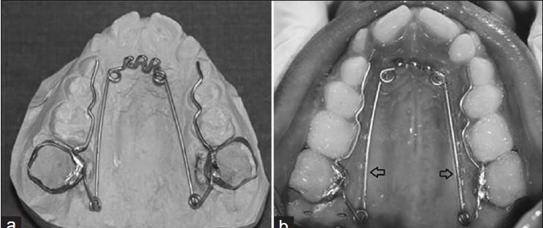Habit of prolonged sucking beyond the age of 5 years can lead to various types of malocclusion like open bite, cross bite, increased overjet, crowding and increased probability of developing Class II malocclusion with flared and spaced maxillary incisors, lingually positioned lower incisors (or sometimes labially, with reverse occlusion, depending on sucking technique), anterior open-bite, narrow upper arch, cross-bite.16 Usually, if anterior open bite occur due to thumb sucking, a secondary tongue thrust develops leading to the exaggeration of the condition.17 Speech problems, including mispronouncing T and D, lisping, and thrusting out the tongue when talking, can be seen. 18 A study by Elise Baker concluded that, no phonological impairment is seen in young children with nonnutritive sucking habit by use of pacifier.19 In a study by Hiu Tung Bonnie Ling et al. it was concluded that,with more than one year of daily pacifier use and thumb/digit sucking habit in children, cause high possibility of Class II incisal relationships, Class II canine relationships and increased overjet with anterior open bite in the primary dentition.20 The best preferred treatment time is late primary or early mixed dentition stage as it is seen that in majority cases, prior to eruption of the permanent teeth if the activity is discontinued, minor tooth changes are resolved.21

**FACTORS ASSOCIATED WITH THUMB SUCKING 4**

Factors like age of child, socioeconomic status of parents, working mothers, number of siblings etc. could influence the habit of thumb sucking.

## TREATMENT

Counselling, remainder therapy, reward system and adjunctive therapy are the 4 approaches to treat thumb sucking habit.20

When reminder and the reward therapy fails,appliance therapy or adjunctive therapy may be used.

PREVENTIVE THERAPY- It includes avoiding the habit to start at first, or use of dummy,pacifier instead of thumb sucking. 4

**PSYCHOLOGICAL THERAPY/COUNSELLING THERAPY**

– Time-out refers to the act in which if the habit occurs, a reinforcer is removed .For example, a mother could stop reading a story whenever thumb-sucking occurred and resume reading story when the child removed his/her thumb from their mouth.Positive reinforcement refers to act such as verbally praising the absence of sucking or placing reward stickers on a calendar.22 Beta Dunlop hypothesis which states that if patient is made to stand and observe himself doing the act.This helps him to stop it in a better way.4

**CHEMICAL TREATMENT-**

It includes application of foul tasting things like asoefetida, quinine, pepper on the hand of child as these bitter and sour chemicals will avoid the child to place thumb in the mouth. It is generally used in patients who are at an initial stage and are not very involved in the activity.4

**MECHANOTHERAPY/REMINDER THERAPY**

It can be intraoral and extraoral.

1. INTRAORAL includes:

I(a)- Modified quad helix- Quad helix was with 3 cribs, continuous with the anterior helices and the posterior component. The expansion arms extended up to the primary canine region. The crib acted as a habit breaking part.23 (Fig 1).

Fig 1- Modified quad helix

I(b)- Hybrid Habit Correcting Appliance (HHCA)- It is used in patients in constricted maxilla and posterior cross bite which is a result of both thumb sucking and tongue thrusting habit. The appliance consists of a tongue bead, a palatal crib and a U-loop attached to the molar bands on either sides. The bead works as a reminder, palatal crib works as a reminder and physical restrainer. U loop is useful for the retraction phase in fixed orthodontic therapy.17 (Fig 2)

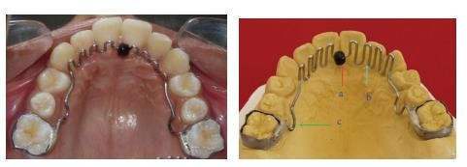

Fig 2 – Hybrid Habit Correcting Appliance

I(c)- Palatal crib- The tooth that act as abutment is the permanent first molars or the primary second molars with a wire of 0.04-inch stainless steel orthodontic wire extending anteriorly along the palate. The wire forms a crib at the level of the maxillary canines, which extends vertically lingual to the level of the incisor edges of the lower anterior teeth.24

Palatal rakes and lingual spurs can also be used.

I(d)-Blue grass appliance- It is a fixed appliance with Teflon roller.The Teflon roller acts a reminder.25 (Fig 3)

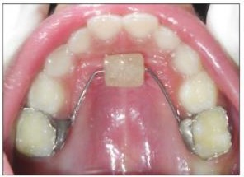

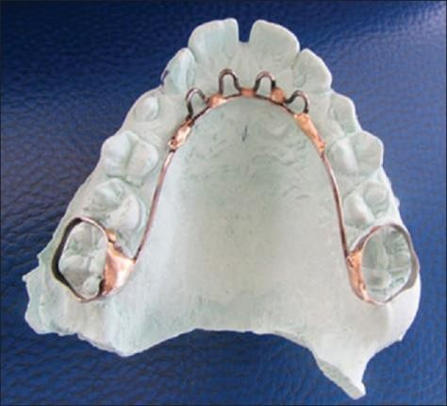Addy et al.reported increased chances of candidal infection in patients with use of fixed/removable appliance.26

I(e)-‘Invisalign Teen’- This is usually a preferable treatment in adolescent patients. Orthodontic aligners are also used for removing the habit of thumb sucking. On the occlusal aspect,small areas of the aligners were flipped like on the palatal surface of the upper incisors creating the effect of bite ramp.

This prevented the placement of thumb in mouth27 (Fig 4)

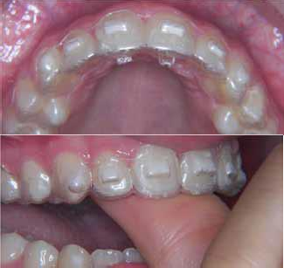

Fig 4 – Invisalign Teen – aligners placed on palatal surface

I(f)- Light emitting diode habit breaking appliance- The appliance consists of Hawley's fabrication with light-emittingdiode bulb and switch attached to it. When the child's tongue or the finger touches the appliance,for the act to suck the thumb, the light bulb gets illuminated acting as a reminder.The associated theory behind this is psychological re-rooting of the patient's action.28 (Fig 5)

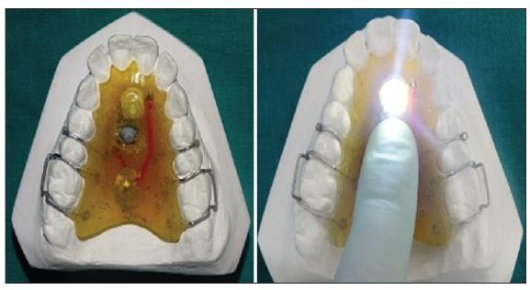

Fig 5- Light emitting diode habit breaking appliance

I(g)- Sudipta Kar’s cribbed thumb guard- Habit breaking appliance with palatal crib was fixed intraorally. (Fig 6) Thumb guard with 3 cribs and two holes are made in the opposite side of the cribs to incorporate one smooth elastic band into the appliance. It was made on duplicate thumb, after taking impression from alginate (Fig 7)

Fig 6- Palatal crib intraoral component of Sudipta Kar’s cribbed thumb guard

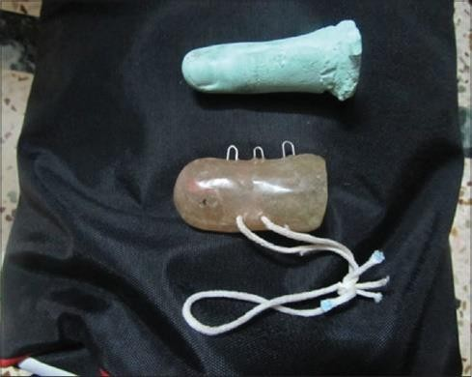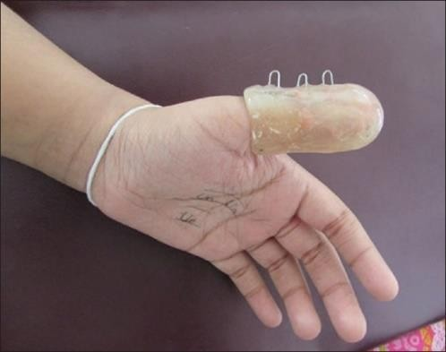

Fig 7 - Thumb guard with cribs made on duplicate alginate thumb

1. EXTRAORAL includes:

II (a)-RURS elbow guard- RURS elbow guard is an extraoral appliance for antithumb sucking. (Fig 8). An acrylic elbow guard was made with cast impression of elbow at 45-60 degree. It was tied with Velcro straps. It does not affect the oral status of the patient.30

Fig 8- RURs elbow guard tied with Velcro strap

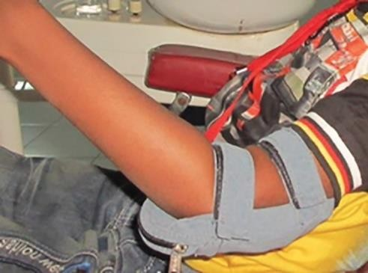II (b)-Modified RURS elbow guard with the conventional design but modified length of the appliance extended at both the ends by2.5 inches worked the same for anti thumbsucking.31 (Fig. 9)

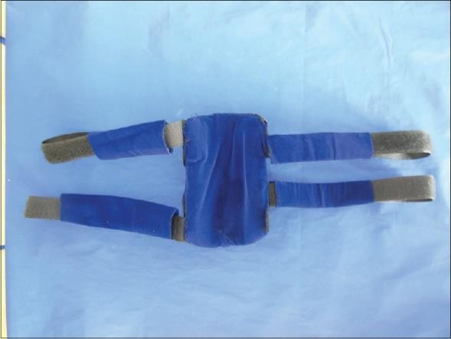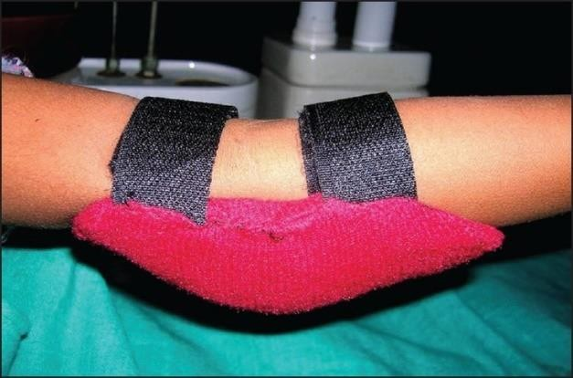 Fig 9 - Modified RURS elbow guard

II (c)-Modified three- alarm system- Three alarm system initially was introduced by Norton and Gellin in year 1968. Later it was revised to overcome the drawbacks like, pin prick or injury to elbow. The modified three alarm system had an acrylic elbow guard with a musical chip and speaker incorporated carefully on the outer side of the acrylic (Fig 10). The switch button was placed in the inner side of the acrylic elbow guard with a zip and velcro strap cover over the acrylic elbow guard for retention of the appliance. (Fig11) So, whenever, the child tries to suck the thumb or digit the switch button was pressed by the elbow joint and music would play loud marking as reminder to stop the habit.32 (Fig 12)

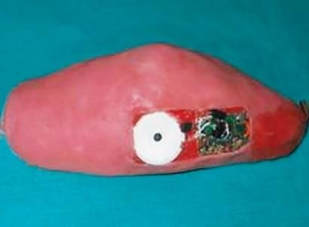

Fig 10- Modified three alarm system- an acrylic elbow guard with a musical chip and speaker incorporated carefully on the outer side of the acrylic

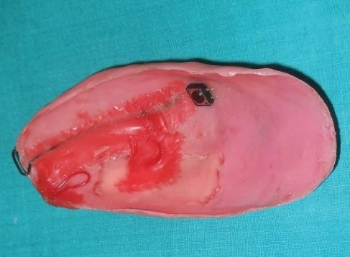

Fig 11- The switch button was placed in the inner side of the acrylic elbow guard

Fig 12- Patient wearing the modified three alarm system

II (d)-Alarming wrist watch- A new device with an alarm placed inside a wristwatch, that was activated when the child tried to move the finger towards and place into the mouth.33

(Fig 13) and (Fig 14)

Fig 13- Alarming wrist watch

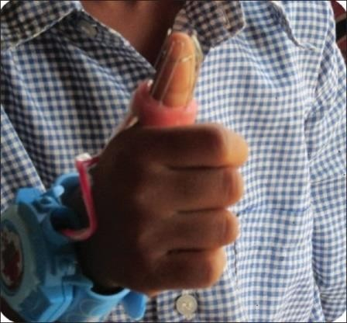

Fig 14- Child wearing the alarming wrist watch

Other methods include use of hand puppet, long sleeve night gowns. 4

**CONCLUSION**

The treatment approach of a child with thumb sucking is based on their willingness and severity of the act. The choice of treatment plan must be carefully done keeping in mind the psychological aspect of the child, also. The role of pedodontist is for early intervention as it can prevent the chances of malocclusion due to the habit, at later stage.

**REFERENCES**

1. Chen X, Xia B, Ge L. Effects of breast- feeding duration, bottle-feeding duration and non-nutritive sucking habits on the occlusal characteristics of primary dentition. BMC Pediatr.2015 Dec;15(1):1- 9.
2. Khayami S, Bennani F, Farella M. Fingers in mouths: from cause to management. NZ Dent J. 2013 Jun 1;109(2):49-50

.

1. Dorland’s Medical dictionary
2. 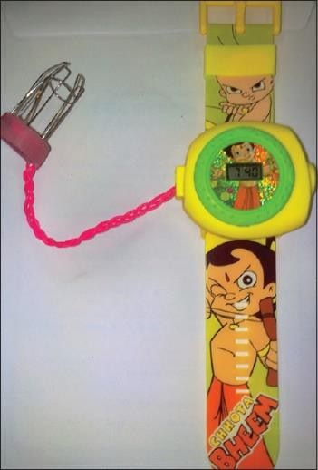Marwah N.Oral habits.In: Marwah N.editor. Textbook of Pediatric Dentistry. 3rd ed. Jaypee Brothers Medical Publishers: 2014.p.358-65.
3. Subtelny JD, Subtelny JD. Oral habits-- studies in form, function, and therapy. The Angle Orthodontist. 1973 Oct;43(4):347- 83.
4. .Dhull KS, Verma T, Dutta B. Prevalenceof deleterious oral habits among 3-to 5- year-old preschool children in Bhubaneswar, Odisha, India. Int J Clin Pediatr Dent.2018 May;11(3):210-3.
5. Vishnoi P, Kambalyal P, Shyagali TR, Bhayya DP, Trivedi R, Jingar J. Age-wise and gender-wise prevalence of oral habits in 7–16-year-old school children of Mewar ethnicity,India.Indian JDent.2017Jul1;9(3):184-8
6. Colleen A., Ryan, Gary J., Gosselin, David R. DeMaso (eds):Nelson text book of pediatrics: Habit and Tic Disorders.19th ed. Philadelphia: WB Saunders; 2011. p 112.
7. Yemitan TA, Sanu OO, Isiekwe MC. Effects of digit sucking on dental arch dimensions in the primary dentition. Afr J Med Med Sci. 2010 Mar 1;39(1):55-61.
8. Farsi NM, Salama FS, Pedo C. Sucking habits in Saudi children: prevalence, contributing factors and effects on the primary dentition. Pediatr Dent. 1997 Jan 1;19:28-33.
9. .Warren JJ, Bishara SE. Duration of nutritive and nonnutritive sucking behaviors and their effects on the dental arches in the primary dentition. Am J Orthod Dentofacial Orthop. 2002 Apr 1;121(4):347-56.
10. .Jyoti S, Pavanalakshmi GP. Nutritive and non-nutritive sucking habits–effect on the developing oro-facial complex; a review. Dentistry. 2014 Jan 1;4(3):1-4.
11. Warren JJ, Slayton RL, Yonezu T, Bishara SE, Levy SM, Kanellis MJ. Effects of nonnutritive sucking habits on occlusal characteristics in the mixed dentition. Pediatr Dent. 2005 Nov ;27(6):445-50.
12. Thumb sucking and pacifier use.JADA.2007 Aug; 138(8):1176
13. Graber TM. Orthodontics-Principles and Practices, 3rd ed. Philadelphia: Saunders Co; 1972.p.512-14
14. Proffit WR, Fields HW, jr, Sarver MD. Early stages of development, The etiology of orthodontic problems.In: ContemporaryOrthodontics. 4th Ed. Mosby, Elsevier; 2007.p. 154.
15. Abraham R, Kamath G, Sodhi JS, Sodhi S, Rita C, Sai Kalyan S. Habit breaking appliance for multiple corrections. Case reports in dentistry. 2013 Jan 1;2013.
16. Tewari A. Abnormal oral habits relationship with malocclusion and influence on anterior teeth. Journal of the Indian Dental Association.1970 Mar 1;42(3):81-4.
17. Baker E, Masso S, McLeod S, Wren Y. Pacifiers, thumb sucking, breastfeeding, and bottle use: oral sucking habits of children with and without phonological impairment. Folia Phoniatr Logop.2018;70(3-4):165-73.
18. Ling HT, Sum FH, Zhang L, Yeung CP, Li KY, Wong HM, Yang Y. The association between nutritive, non- nutritive sucking habits and primary dental occlusion. BMC Oral Health.2018 Dec;18(1):1-10.
19. Feştilă D, Ghergie M, Muntean A, Matiz D, ŞERBǍNESCU A. Suckling and non-nutritive sucking habit: what should we know?. Clujul Med. 2014;87(1):11-4.
20. Reddy D, Dawjee SM. Treatment of thumb-sucking habit using a fixed tongue crib appliance-a case report and literature review.. S Afr Dent J. 2019 Jun;74(5):239-42.
21. Vinay C, Sandeep V, Rao CH, Uloopi KS, Kumar AS. Modified quad helix appliance for thumb sucking and cross bite correction. Contemp Clin Dent. 2013 Oct;4(4):523-6.
22. Akkiela DA, Al Natsha RR, Salama F. Management of Thumb Sucking During Early and Late Mixed Dentition Using Palatal Crib: Report of Two Cases. Int J Med Sci Clin Invent. 2017;4(2):2646-50.
23. Shwetha G, Shetty AK, Chandra P, Anandakrishna L. Bluegrass appliance for thumb sucking habit: A case report. IntJ Med and Dent Case Rep. 2014;1(1):1-3.
24. Addy M, Shaw WC, Hansford P, Hopkins M. The effect of orthodontic appliances on the distribution of Candida and plaque in adolescents. Br J Orthod.1982 Jul;9(3):158-63.
25. Levrini L, Tettamanti L, Macchi A, Tagliabue A, Caprioglio A. Invisalign teen for thumb-sucking management. A case report. Eur Arch Paediatr Dent. 2012 Feb;13(2):155-58.
26. Sahu A, Shyagali TR. A new innovative light-emitting diode habit-breaking appliance. Ind J Multidiscip Dent. 2017 Jul 1;7(2):149-53
27. Kar S, Pal A. Sudipta Kar's cribbed thumb guard: An innovative inexpensive way to treat thumb sucking. International Journal of Health & Allied Sciences. 2019 Jul 1;8(3):197-200
28. Shetty RM, Dixit U, Hegde R, Shivprakash PK. RURS'elbow guard: An innovative treatment of the thumb-sucking habit in a child with Hurler's syndrome. J Indian Soc Pedod Prev Dent.2010 Jul 1;28(3):212-5
29. Anand S, Hegde DY, Yeluri R, MasihU. Modified RURS'elbow guard: An extraoral appliance for the digit sucking habit. International Journal of Pedodontic Rehabilitation. 2017 Jan 1;2(1):34-6
30. Shetty RM, Shetty M, Shetty NS, Deoghare A. Three-alarm system: revisited to treat thumb-sucking habit. Int J Clin Pediatr Dent. 2015 Jan;8(1):82-4.
31. Krishnappa S, Rani MS, Aariz S. Newelectronic habit reminder for the management of thumb-sucking habit. J Indian Soc Pedod Prev Dent2016 Jul 1;34(3):294-6