**REVIEW ARTICLE**

***Clear Aligner A To Z- A Review***

Anil Sharma1, Sumedha Sen2, Joyshree Chutia2, Shivani Kumari2



**ABSTRACT**

*Adult patients seeking orthodontic treatment are increasingly motivated by esthetic considerations. The majority of these patient reject wearing labial fixed appliances and are looking instead to more esthetic treatment options, including lingual orthodontics and invisible appliances. Since Align Technology introduced the Invisalign appliance in 1999 in an extensive public campaign, the appliance has gained tremendous attention from adult patients and dental professionals. The transparency of the Invisalign appliance enhances its esthetic appeal for those adult patients who are averse to wearing conventional labial fixed orthodontic appliances.  A few recent studies have outlined some of the limitations associated with this technique that clinicians should recognize early before choosing treatment options.*

Keywords: clear aligners, invisalign



**INTRODUCTION**

Clear aligners, are orthodontic devices that are a transparent, plastic form of dental braces used to adjust teeth. With the recent increase in adults seeking orthodontic treatment, there has been a corresponding increase in demand for appliances that are both more aesthetic and more comfortable than conventional fixed appliances.1

Movement of teeth without the use of bands, brackets, or wires was described as early as 1945 by Dr HD Kesling , who reported on the use of a flexible tooth positioning appliance .

To quote Kesling, " This new appliance grew out of a desire to create some simple appliance that would influence all of the teeth to flow into their best possible position with relation to one another without any interference from bands or wires, that would be effective under functional forces , that  would produce arch forming in accordance with type , that would further attain the desired harmony between facial features and tooth arrangement , and that would serve as a retainer to conserve all the advantages gained above."2

1*.Professor Department Of Orthodontics & Dentofacial Orthopedics Kothiwal Dental College & Research Centre*

*2.Post Graduate Student*

***Correspondence Address:***

*Dr. Sumedha Sen*

*Post Graduate Student*

*Department of Orthodontics & Dentofacial Orthopedics,*

*Email id:* [*urssumedhasen@gmail.com*](mailto:urssumedhasen@gmail.com)

Phone no.- 7631362042

Align Technology, Inc. (Santa Clara, Calif ), introduced the Invisalign system several years ago in 1997. Invisalign takes the principles of Kesling, Nahoum, Raintree Essix and others even further, using computer aided design ̶̶ computer aided manufacture (CAD - CAM) technology combined with laboratory techniques to fabricate a series of custom appliances that are esthetic and removable, and that can move teeth from beginning to end. 4 By applying 3D imaging technology to the principle of moving the teethwith a series of aligners, mass - customization,i.e. the production of individual appliances on a large scale, became reality. Because growth changes could not be predicted, the method would be useful primarily for treatment of adults or late adolescents, these are the patients more interested in an invisible or minimally visible orthodontic appliance. 5

**GENERATION OF CLEAR ALIGNERS 6**

**First Generation**: Earliest form of these systems were solely reliant on the aligner to achieve their results. (Figure 1)

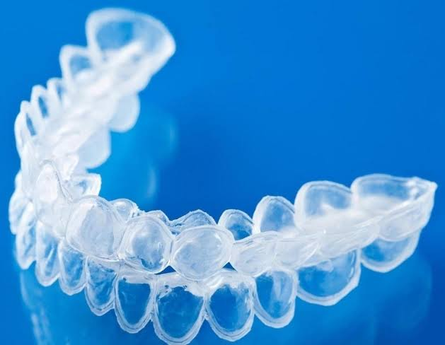

*Figure 1: - aligner without any attachments*

**Second Generation**: Makes use of attachments to improve tooth movements. Clinicians could request composite buttons to be placed on the teeth and could also start to use inter maxillary elastics. (Figure 2)

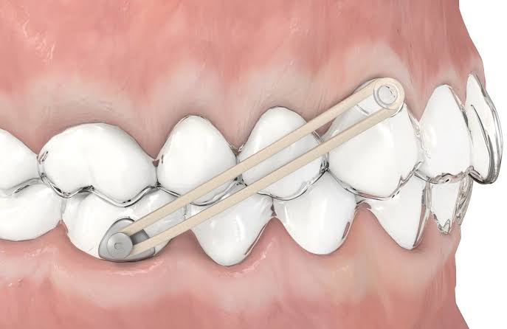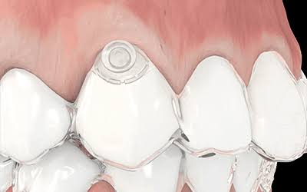

*Figure 2: - showing precision attachments used for intermaxillary elastics*

**Third generation**: In an effort to improve the results and achieve better control of tooth movements with aligner appliances, attempts have been made to alter the way aligners deliver force. Attachments are now placed automatically by the manufacturer’s software where extrusions, derotations and root movements are required. Indentations in the aligners are fabricated where root torque is needed. The operator can also request non-precision attachments to be placed on the teeth where it is felt that they would improve the movements achieved. There are three common types of attachments: ellipsoid, bevelled and rectangular.

*Ellipsoid attachments* are used singly for de-rotations, or in pairs where root movements are attempted. They are 3 mm high, 2 mm wide and 0.75–1 mm thick and are available for incisors, canines and premolars. When they are used singly, similar to the development of wider brackets in fixed appliances, ellipsoid attachments should allow for greater rotational control. Using them in pairs should allow for production of moment of couple (MoC) to upright roots.They may also allow the appliance to achieve bodily movement, like labial brackets, through the use of MoC and Moment of Force (MoF) (Figure 3).





*Figure-3: - Schematic and clinical representations of ellipsoid precision attachment used for derotating a canine*

*Bevelled attachments* are used most often when trying to extrude a tooth (Figure 4). They can be 3, 4 or 5 mm wide, 2 mm high and from 0.25 to 1.25 mm thick. They have an active border, just like fixed brackets, that should limit the slipping (or loss of tracking) that can occur between the aligner and the tooth.



*Figure-4: - Schematic and clinical representations of bevelled precision attachments used to extrude maxillary central*

*Rectangular attachments* are used when large mesio-distal movements are requested. These are 3, 4 or 5 mm high, 2 mm wide and 0.5 to 1 mm thick. It is proposed that these attachments will allow teeth to be moved bodily by allowing for a longer span for force application (Figure 5).



*Figure 5: - Clinical photograph & Schematic representation of rectangular precision attachments used to close mesio/ distal spacing.*

**INDICATIONS**

* Class 1 spacing with minor / moderate crowding and existing good buccal occlusion (crowding and spacing of 1 to 5 min)
* Half - cusp Class II with minor crowding
* Class III with minimal overbite / overjet
* non - extraction cases
* deep overbite problems (e.g. Class II division 2 malocclusions) when the overbite can be reduced by intrusion or advancement of incisors
* Anterior open bite
* non - skeletally constricted arches that can be expanded with limited tipping of the teeth
* Tip molars distally
* Lower incisor extraction
* Premolar extractions with minor crowding
* Orthognathic surgery 8
* mild relapse after fixed - appliance therapy
* It was successfully used by Boyd in conjunction with segmental fixed appliances, or with full fixed appliances used immediately before and after surgery for certain skeletal Class III malocclusions9.

**THE ALIGNER PROCESS**

Although diagnostic preparation for treatment with the Invisalign appliance is similar to that for treatment with conventional fixed orthodontic appliances, clinicians play a more limited role during treatment with the Invisalign appliance. Preparation includes initial assessment, diagnosis, treatment planning and completion of pre-treatment records (e.g., panoramic and lateral cephalometric radiographs, bite registration, photos and polyvinyl siloxane impressions), all of which must be sent to Align Technology in California where simulated virtual treatment is formulated by proprietary 3-dimensional CAD-CAM technology. Clinicians then download the virtual treatment set-up from the internet to evaluate the proposed final positioning of the teeth. Clinicians can request modifications at this time, but once the aligners are made, they cannot alter the appliance during the treatment.  As a consequence, clinicians must prospectively formulate a precise treatment plan. If the results are unsatisfactory, clinicians may use auxiliary appliances (e.g., fixed braces) or contact Align Technology for adjustment and fabrication of new aligners.

Hence, a series of aligners is made from a transparent, thin (typically less than 1 mm) plastic material formed with CAD - CAM laboratory techniques.Each aligner is designed to move the teeth a maximum of about 0.25 to 0.3 mm over a 2- week period, and is worn in a specific sequence.  The Invisalign appliance is currently recommended for adults and for adolescents with fully erupted permanent teeth who meet an acceptable standard of compliance.  Excellent compliance is mandatory since the appliance has to be worn a minimum of 20 to 22 hours a day and each aligner should be worn 400 hours to be effective.10

**ADVANTAGES OF THE INVISALIGN SYSTEM**

* In contrast to fixed orthodontic appliances, Invisalign aligners are removable, this allows patient to maintain their current oral hygiene practices. Patient can brush and floss normally. Also, patients do not need to change their diet or eating habits. Thus reducing the incidence of demineralization and periodontal disease. 3
* Unlike treatment with fixed appliances, treatment with clear, removable aligners appears to have no adverse effect upon gingival health.11
* The Invisalign system eliminates the esthetic issue with labial fixed appliances and, in contrast to lingual fixed appliances, interferes minimally with the tongue movements and speech. This makes it the treatment of choice mostly by adult female patients who are not prepared to accept the appearance of fixed appliances or their effect upon speech.12
* During periodical removal of the aligners for eating, drinking and cleaning of both the teeth and the appliance, the periodontal ligament is given a chance to recover thus, in theory, causing less discomfort.14
* Therapy with aligners should carry a reduced risk of root resorption by virtue of the fact that teeth are moved by no more than 0.2 mm at a time, which hints at a relatively low force.  This assumption was investigated by Barbagallo and his co-workers in a prospective, randomized clinical trial using microcomputed tomography.15

**LIMITATIONS OF THE INVISALIGN SYSTEM**

1. A significant limitation of the Invisalign system is the inability to alter the course of treatment once the set of aligners has been fabricated.
2. While the Invisalign system is aesthetically pleasing, it requires basically the same treatment time as other types of orthodontic appliances. 3
3. The basic component of Invisalign aligners, polyurethane, is not an inert material.  It is affected by heat, moisture, and prolonged contact with enzymes, aligners retrieved from the oral cavity demonstrate substantial morphological variation involving abrasion at the cusp tips, adsorption of desquamated cells, and localized calcification of the biofilm in addition, the posterior parts of the appliance were found to increase in hardness, a feature likely caused by cold work of the material during mastication.9
4. In another publication, it became apparent that thermocycling and repeated loading both decrease force delivery.10
5. Treatment outcomes with fixed appliances are, in general,superior to those achieved by utilizing the Invisalign system.3
6. In particular, the Invisalign system is unable to correct large anteroposterior skeletal discrepancies and to achieve optimal occlusal contacts.  In addition, treatment stability was reported as being less than that resulting from fixed appliance therapy.11,12
7. Joffe listed symptoms whose improvement is difficult to achieve when using the system on its own.3

* Malocclusions / symptoms less responsive to treatment with the Invisalign system
* crowding or spacing >5 mm
* Anteroposterior skeletal discrepancies > 2mm,
* Centric relation / centric occlusion discrepancies,
* severe rotations (> 20°);
* Open bites (anterior and posterior),
* Extrusion of teeth;
* Severe hypodontia / oligodontia;
* Uprighting of severely tipped teeth (>45°)

**FUTURE DIRECTIONS**

In reality, the future evolution of orthodontics has already arrived in the present, as clear aligners utilize digital technology for diagnosis, treatment planning, and designing the final occlusal outcome.  To a certain degree, it is possible to customize the biomechanics by staging tooth movements in a specific sequence in the software program.  The rate of tooth movement may also be adjusted according to the individual's bone physiology by altering the scheduled number of days for aligner changes, depending on the individual's response to tooth movement.  The final occlusion set up in the software may be customized according to the individual's dental arch form and preferences for smile esthetics.8

**CONCLUSION**

Fixed orthodontic appliances have been the backbone of orthodontic biomechanical technique.  However, the reluctance to wear buccal braces because of their poor esthetic has been a driving force for the development of alternative treatment options for the adult population. 3

The Invisalign system has been established as an option for the correction of malocclusions in patients who demand a minimally visible, non-speech impairing treatment modality. It is particularly well suited to patients who function in the public arena. Additional advantages include unhindered oral hygiene, a reduction in iatrogenic discomfort, favourableacceptance, and high satisfaction with treatment outcomes by both patients and clinicians. 3

The Invisalign appliance may be a treatment option for simple malocclusions, as Joffe suggests, but it has some limitations, particularly in the management of severe skeletal malocclusions.  Achieving similar results to those of more conventional fixed appliances may be difficult.  Several clinical reports seem to indicate that the limitations of the system can be overcome to some degree by applying clinical expertise and the use of adjunct orthodontic therapies.  The use of the Invisalign appliance in combination with fixed appliances has been explored to reduce the time needed to wear fixed appliances, but may result in significantly higher professional fees overall.  Yet very few prospective clinical trials can be found in the literature. Conversely, the Invisalign appliance can provide an excellent esthetic during treatment, case of use, comfort of wear, and superior oral hygiene.  Additional research and refinement of the design should allow further development of this worthwhile treatment.16

**REFERENCES**

1. Weir [T.Clear](http://T.Clear) aligners in orthodontic treatment Australian dental journal [2017](tel:2017), [62: 58- 62](tel:62 58 62 2)
2. Kesling HD The philosophy of the tooth positioning appliance.  Am J Orthod [1945](tel:1945),31: [297-304](tel:297-304 3)
3. Ali SA, Miethke HR.  Invisalign, an Innovative Invisible Orthodontic Appliance to Correct Malocclusions: Advantages and Limitations Dent Update [2012](tel:2012),[39: 254-260](tel:39 254-260 4)
4. Wong BH, Invisalign A to Z. Am J Onthod DentofacialOrthop [2002](tel:2002),[121: 540-541](tel:121 540-541 5)
5. Proflit WR, Fields Jr HW.  Sarver DM.  Contemporary orthodontics.  Elsevier health Sciences , [2006](tel:2006) Dec 8.
6. Hennessy , J. , & Al - Awadhi , E. A. ( [2016](tel:2016) ) .  Clear aligners generations and orthodontic tooth movement.  Journal of Orthodontics, 43 (1), [68-76](tel:68-76 7)
7. Joffe L. Invisalign early experiences.  J Orthox [2003](tel:2003) , 30 ( 4 ) : [348-352](tel:348-352 8)
8. Tai S. Clear uligner technique.  Illinois Quintessence Publishing , [2018](tel:2018)
9. Schuster S, Eliades G, Zinelis S, Eliades T, Bradley TG. Structural conformation and leaching from in vitro aged and retrieved Invisalign appliances.Am J OrthodDentofacialOrthop2004; **126**(6): 725–728.
10. Kwon JS, Lee YK, Lim BS, Lim YK. Force delivery properties of thermoplastic orthodontic materials. Am J OrthodDentofacialOrthop2008; **133**(2): 228–234.
11. Turatti G, Womack R, Bracco P. Incisor intrusion with Invisalign treatment of an adult periodontal patient. J ClinOrthod 2006; 40(3): 171–174.
12. Giancotti A, Mampieri G, Greco M. Correction of deep bite in adults using the Invisalign system. J ClinOrthod2008; 42(12): 719–726.
13. Nedwed V, Miethke RR. Motivation, acceptance and problems of Invisalign patients.J OrofacOrthop2005; 66(2): 162–173.
14. Barbagallo LJ, Jones AS, Petocz P, Darendeliler MA. Physical properties of root cementum: Part 10. Comparison of the effects of invisible removable thermoplastic appliances with light and heavy orthodontic forces on premolar cementum. A micro-computed tomography study. Am J OrthodDentofacialOrthop2008; 133(2): 218–227
15. Phan X, Ling PH. Clinical limitations of Invisalign. Journal of the Canadian Dental Association.2007 Apr 1;73(3): 263-266