**REVIEW ARTICLE**

***Rapid maxillary expansion – A review***

Dr.Shikha Jain1, Dr.Adeel Ahmed2, Dr.Sayantan Choudhury3, Dr.Kanchan Das4,Dr.Arunavo Nandy5

***Abstract***

Transverse maxillomandibular discrepancies are a major component of several malocclusions. Clinicians frequently expand the maxilla to correct a maxillary transverse deficiency (MTD) in patients. Our aim in this article is to present a comprehensive review of the literature, including indications, contraindications, diagnosis and guidelines for case selection, a brief overview of various banded and bonded (Rapid Maxillary Expansion) RME appliances, effects of RME, clinical tips regarding RME to better aid the clinician in the management of MTDs.

*Keywords: Rapid Maxillary Expansion (RME), Maxillary Transverse Deficiency (MTD).*

**INTRODUCTION**

Orthodontic practice is concerned with lack of space – in transverse and sagittal direction. Orthodontic philosophies over the years have vacillated between a strict non-extraction approach and the extraction of teeth1.

Since Angell introduced RME in 1860, expansion appliances of various designs have been an integral part of orthodontic treatment2. There has been an evolution of fixed and removable appliances to expand palatal arches. Rapid Maxillary Expansion is commonly used for gaining space with the added advantage of being a conservative procedure. Along with this the expansion sometimes moves the maxilla forward a little (but is about as likely to lead to backward movement ), increases space in the arch, and repositions underlying permanent tooth buds as they move along with the bone in which they are embedded1.

1. *Professor*

*Department Of Orthodontics &DentofacialOrthopedicsKothiwal Dental College & Research Centre*

1. *Senior Lecturer*
2. *Post Graduate Student*
3. *Post Graduate Student*
4. *Post Graduate Student*

***Correspondence Address:***

*Dr.Sayantan Choudhury*

*Post Graduate Student*

*Department of Orthodontics &Dentofacial Orthopedics, Email id:* [*sayantanmodak@gmail.com*](mailto:sayantanmodak@gmail.com)

Phone no.- 7278444132

**Indications for RME2:**

(1)Posterior crossbite (unilateral/bilateral) associated with relatively narrow maxilla.(2). Elimination of inter-arch transverse discrepancies prior to orthopaedic intervention in class II malocclusions. (3). Correction of Class III malocclusion of skeletal or dental origin. (4). SARPE (surgically assisted rapid palatal expansion ) in adult skeletal posterior crossbitesalongwith surgery. (5). Cleft palate patients with collapsed maxillary arch. (6). Alongwith facemask in maxillary deficiency cases to loosen the circum maxillary sutures and facilitate the protraction of maxillary basal bone. (7). Increases supplementary arch perimeter to accommodate teeth in patients with tooth size-arch length discrepancies. (8). Medical indications for RME are: • Poor nasal airway. Rapid Max• Septal deformity. • Recurrent ear, nasal or sinus infections. • Allergic rhinitis. • Asthma. • As a preliminary to septoplasty.

**Contraindications for RME2 :**

A. Absolute Contraindications- 1. Single tooth crossbite. 2. Existing anterior open bite. 3. Steep mandibular plane and convex profiles with vertical growth pattern.4. In uncooperative patients.

B. Relative contraindications- 1. Ossified midpalatal suture is completed. 2. Periodontally weakened molars. 3. Normal buccal occlusion with good interdigitation of cusps and fossa.

**Advantages2:**

1. Delivers a constant physiologic force until the required expansion is obtained.
2. Requires minimal adjustment throughout its use.
3. Minimum tipping of anterior teeth.
4. Least strain is exerted on anchored teeth.

**Disadvantages2:**

1. Pain and discomfort due to heavy forces used.
2. Requires patient/parent cooperation in activation of appliance.
3. Labor-intensive procedure in fabrication of appliance.

**Diagnosis3:**

The first step in the case selection process is determination of MTD. Clinical evaluation, model analysis, occlusograms, and radiographic measurements have been recommended for an accurate assessment.

Clinical evaluation includes assessment of the maxillary arch form and symmetry, shape of the palatal vault, width of the buccal corridors on smiling, occlusion, and predominant mode of breathing (nasal or oral). Excessively wide buccal corridors, paranasalhollowing, or narrow alar bases, unilateral or bilateral crossbite, severe crowding, a V-shaped or ahourglassshaped occlusion, and a high palatal vault usually suggest MTD. Another factor that needs assessment is a mandibular shift on closure, which can often lead to chin deviation with a unilateral crossbite. To identify the nature of a shift, it might be necessary to use a muscle deprogramming device such as a bite plate for a few days. Such a deprogramming device allows the muscles to move the mandible in coordinated function that is undisturbed by deflective tooth contacts.4,5

Another aspect that needs determination is whether the MTD is relative or absolute.6 This is essential in the evaluation of sagittal discrepancies (especially Class III malocclusion). An attempt is made to articulate and align the models in Angle Class I molar and canine relationship to evaluate arch coordination. Relative MTD implies that the apparent deficiency is the result of the discrepancy of the maxilla or both jaws in the sagittal plane. Absolute MTD implies a true horizontal width insufficiency3.

Study models should be used to thoroughly assess the arch form and the shape and make specific measurements to evaluate for MTD. Several indexes have been proposed by various authors to measure lateral discrepancies. The most common include the indexes of Pont, Linder-Harth, and Korkhaus.7With the advent of digital models in routine clinical practice, additional tools can be used to evaluate arch form and tooth inclinations.8

The evaluation of the buccolingual inclination of the posterior teeth allows a more accurate distinction between dental and apical base skeletal MTD. The digital models can be viewed in desired cross-sections that permit better visualization of the buccolingual inclination of the teeth. The digital models can also generate images for occlusograms9,10whereby the coordination of the maxillary and mandibular arches can be evaluated. They provide occlusal simulations and assist in the diagnosis of relative or absolute MTD.

Lehman et alrecommended a palatal or an occlusal radiograph as an essential tool to evaluate the ossification of the midpalatal suture.11However the value of an occlusal radiograph is unclear, since studies have shown that the midpalatal suture does not offer much resistance to expansion.12,13

Betts et al suggested that posteroanteriorcephalograms are the most readily available and reliable means to identify and evaluate transverse skeletal discrepancies between the maxilla and the mandible.14 Using cephalometric landmarks as described by Ricketts, they presented 2 methods for quantification of the MTD: maxillomandibular width differential and maxillomandibular transverse differential index.15

The advent of 3-dimensional imaging techniques is the most recent tool for diagnosis that have enabled an accurate visualization of the craniofacial region. It allows for evaluation of the spatial relationships of various areas of the jaws.16

**Guidelines for case selection17:**

(1) One should consider if the magnitude of the discrepancy between the maxillary and mandibular first molar and premolar widths is 4 mm or more

(2) The severity of the crossbite, single or multiple.

(3) The initial angulation of the molars and premolars are important because if the maxillary molars are buccally inclined, conventional expansion will tip them further into the buccal musculature and if the mandibular molars are lingually inclined, the buccal movement to upright them will increase the need to widen the upper arch.

(4)The optimal age for expansion is, before 13 to 15 years of age. Although it may be possible to accomplish expansion in older patients, the results are neither as predictable nor as stable.

**Classification of Rapid Maxillary Expansion:**

1. Conventional RME
2. MARPE (Miniscrew assisted rapid palatal expansion)
3. SARPE (Surgically assisted rapid palatal expansion)
4. **Conventional RME**

**Expansion Appliances:**

**Types-** [1] Banded Appliances

[2] Bonded Appliances

**[1] Banded Appliances2**: Requires banding of teeth for screw attachment.

**Tooth and tissue borne appliances-**

1. Derichsweiler type- Tags are welded and soldered to the palatal aspects of the bands to provide attachments for the acrylic which is also extended to the palatal aspects of all banded teeth except the incisors(Fig No. 1.a).
2. Hass type- A length of 0.045 inch stainless steel wire is welded and soldered along the palatal aspects of the bands. The free ends are turned back and embedded in the acrylic base which stops short of the split acrylic base (Fig No. 1.b).

**Tooth borne appliances-**

1. Isaacson type- This appliance uses a special loaded screw called Minne expander. It is a heavy caliber coil spring that is expanded by compressing the coil. The Minne expander is adapted and soldered directly to the bands without the use of acrylic. The screw may be reduced in length to suit narrow arches by shortening the spring, tube and rod(Fig No. 1.c).
2. Biedermann or Hyrax type- This appliance requires a special screw, either hyrax, or Unitek. These have extensions in heavy gauze wire which are welded and soldered to the palatal aspects of the bands(Fig No. 1.d).

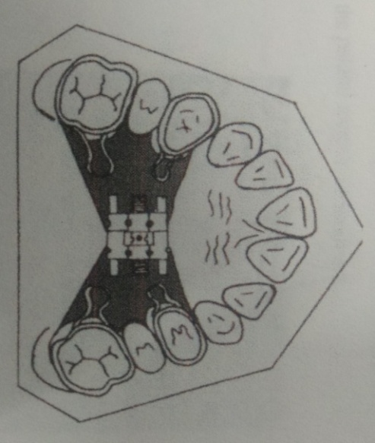

1.a

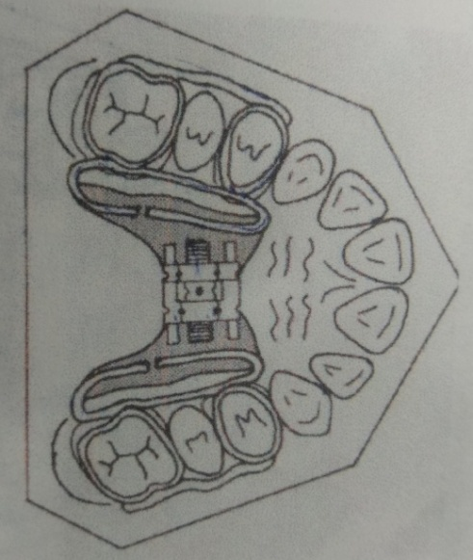

1.b

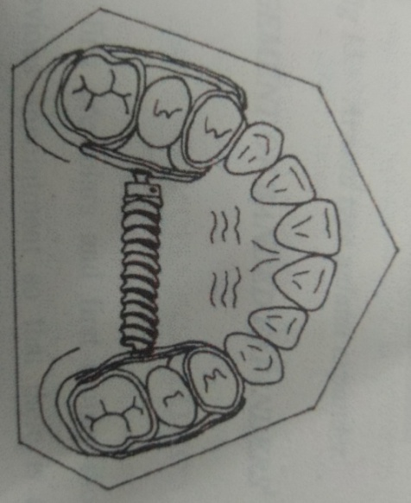

1.c

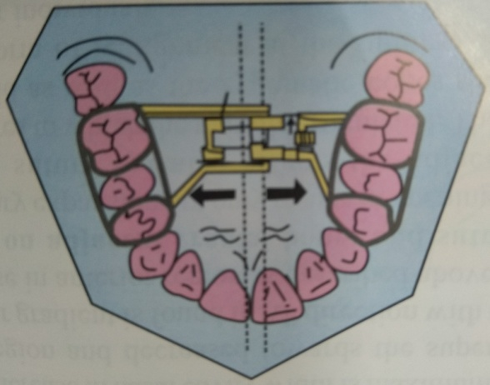

1.d

**Fig.1** a) Derichsweller type b) Hass type c) Isaacson type d) Biedermann or Hyrax type

**[2] Bonded Appliances18**: This are clinically bonded on the teeth.

**A. Full covered bonded rapid maxillary expander-**

The appliance design incorporates the use of a spider-type rigid expansion screwtodeliverthemechanical force for lateral maxillary displacement. The design provides for solely tooth-borne anchorage of fully covered bonded buccal segments(Fig No. 2a & b).

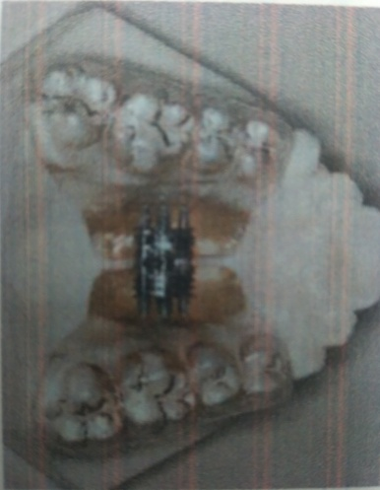

a

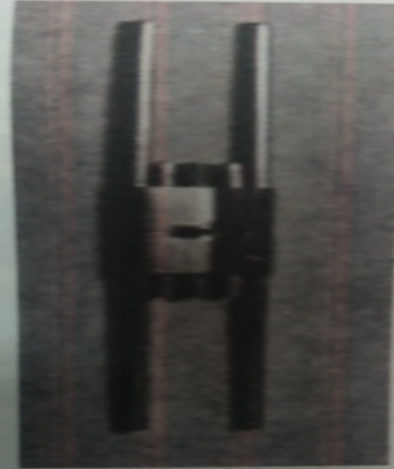

B

**Fig.2**a) Full bonded expansion appliance. b) Spider type of expansion screw

**B. Bonded RME with wire framework around the tooth surface19:**

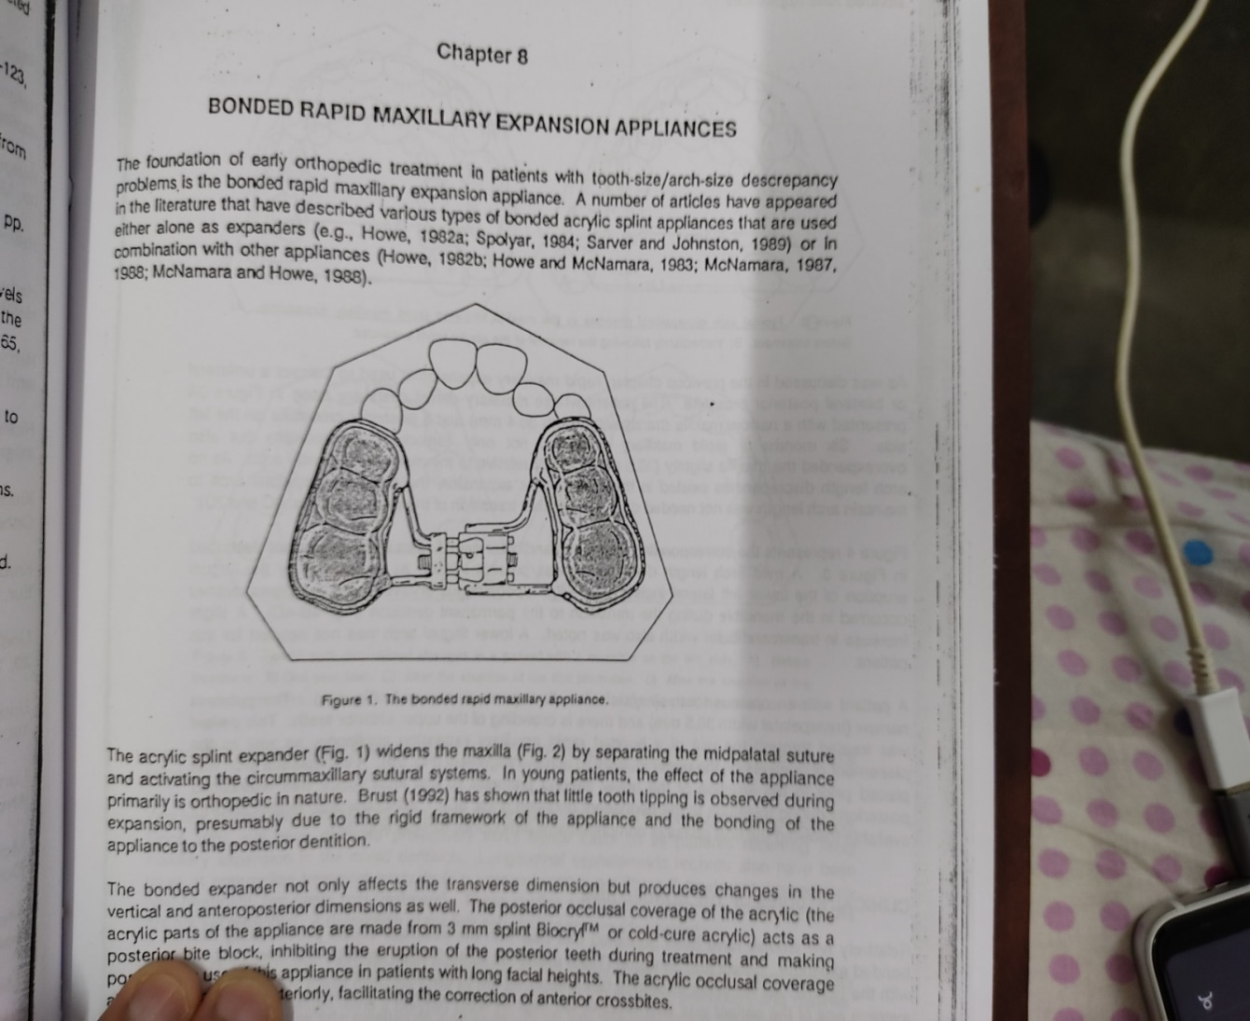

**Fig.3** The bonded rapid maxillary appliance

1. **MARPE (Miniscrew Assisted Rapid Palatal Expansion)20**:

MARPE is a simple modification of a conventional RPE appliance. The main difference is the incorporation of micro-implants into the palatal jackscrew to ensure expansion of the underlying basal bone, minimizing dentoalveolar tipping and expansion.

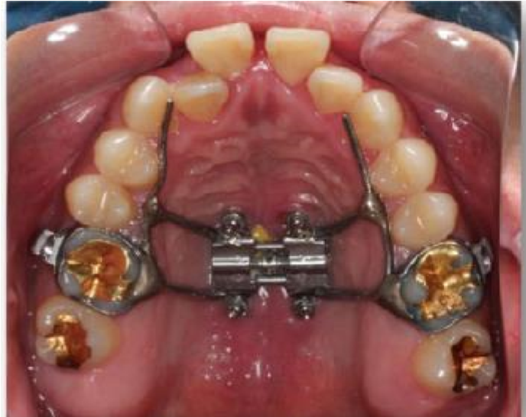

**Fig. 4** MARPE

Tausche et al. reported that a MARPE is a viable expansion technique, allowing for the protection of teeth and preventing buccal tipping of the posterior dentoalveolar segment by 10°. 21

Nienkemper et al. reported that the mentioned side effects of RPE appliances can be minimized using a hybrid hyrax device that is connected to two orthodontic microimplants in the anterior palate and is also attached to the first molars.22

The disadvantages of MARPE are the difficulty in keeping the area clean, the invasiveness of the micro-implants, and the increased risk of infection.

1. **SARPE ( Surgically Assisted Rapid Palatal Expansion):**

The incidence of MTD in the adult population or in skeletally mature people could not be elucidated from the literature review. Because of more complications after attempts to orthopedically alter the transverse dimension of the maxilla with advancing age, surgical procedures have been recommended to facilitate correction of transverse discrepancies. These procedures have conventionally been grouped into 2 categories: segmenting the maxilla during a LeFort osteotomy to reposition the individual segments in a widened transverse dimension, and surgically assisted rapid palatal expansion (SARPE).

**Indications for SARPE3:**

The following have been reported as indications for SARPE, all applying to a skeletally mature patient with a constricted maxillary arch:

1. To increase maxillary arch perimeter, to correct posterior crossbite, and when no additional surgicaljaw movements are planned.
2. To widen the maxillary arch as a preliminary procedure, even if further orthognathic surgery is planned. This is to avoid increased risks, inaccuracy, and instability associated with segmental maxillary osteotomy.
3. To provide space for a crowded maxillary dentition when extractions are not indicated.
4. To widen maxillary hypoplasia associated with clefts of the palate.
5. To reduce wide black buccal corridors when smiling.
6. To overcome the resistance of the sutures when OME has failed.

**Surgical Technique3:**

The surgical technique has been described in 3 stages (Fig 6):

Stage 1A and B: Palatal osteotomy used if the patient is age 25 years and over, or younger if RME has been tried with appliances and has failed. Stage B is same as Stage 1A and indicated where there are bilateral buccalcrossbites.

Stage 2A and B: By the fourth decade, more extensive surgery is required to meet the increasing skeletal rigidity. Over the age of 30 years, lateral maxillary osteotomies are made in addition to the palatal ones.

Stage 3A and B:In patients older than 40 years, Stages l and 2 are supplemented by anterior maxillary osteotomies.

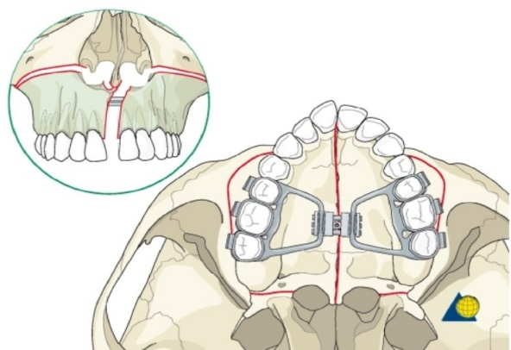

**Fig.5** SARPE

**Clinical Management:**

**Measurements to estimate the amount of expansion3**:

To estimate the need for expansion, measure the distance between the mesiobuccal cusp tips of the maxillary molars (A) and the buccal grooves at the middle of the buccal surfaces of the mandibular first molars (B) Subtract B from A. The mean differences in persons with normal occlusion are +1.6 mm (males) and + 1.2 mm (females).(Fig. 11):

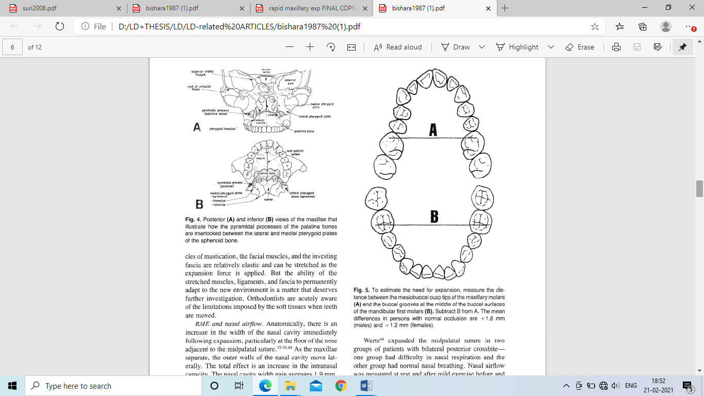

**Fig.6**A- Inter-molar maxillary width measurement B- Inter-molar mandibular width measurement.

The discrepancy between the maxillary and mandibular measurements is a good estimate of how far the maxillary molars must be expanded. One should overexpand the molars 2 to 4 mm beyond the required distance to allow for the expected postfixation relapse. The expansion screw should provide, at least, this calculated amount of expansion. These estimates assume a Class I molar relationship. If the malocclusion will be corrected to a Class II or III molar relationship, the corresponding arch segments should be measured when estimating the amount of expansion necessary.

**Force Application:**

Isaacson, Wood, and Ingram reported that single turns of jackscrew appliance can produce 3 to 10 lb force with cumulative loads of 20 lb or more after multiple daily turns.23The rate of rapid maxillary expansion is 0.2 to 0.5 mm per day. Skeletal changes are approximately 50% of the total change.24-25

Bellconcluded that 3 to 6 months of retention recommended for rapid expansion.26 Mew advocates a total retention period of 1 ½  to 4 years, depending on the extent of expansion.27

**Screw Turn Schedules:**

Zimring and Isaacsonrecommend the following turn schedules: (1) young growing patients-two turns each day for the first 4 to 5 days, one turn each day for the remainder of RME treatment; (2) adult (nongrowing) patients-because of increased skeletal resistance, two turns each day for the first 2 days, one turn each day for the next 5 to 7 days, and one turn every other day for the remainder of RME treatment.28

**Clinical Tips:**

* 1. Extraction of first premolars should be postponed until palatal expansion is completed because these teethtogether with the first molars are often used as abutment teeth for anchoring the appliance.
  2. Avoid orthodontic movement of the maxillary posterior teeth prior to RME because mobile teeth may tip faster during expansion.
  3. For patient comfort and for mechanical advantage, screw should be positioned as superiorly as possible in the palatal vault.
  4. Jackscrew should be turned 15 to 30 minutes after the appliance insertion to allow sufficient setting time for the cementing medium.
  5. A string or dental floss should be tied to turn the key to prevent it from being swallowed and solder the key handle closed to avoid slippage of the floss.
  6. Patient should be examined at regular intervals during the expansion phase of treatment. Distance should be measured between the two halves of the expansion screw to determine how much the screw has been turned.
  7. Midpalatal suture should be monitored weekly with maxillary occlusal films. The suture will open within 7 to 10 days in most patients.29
  8. After the expansion is completed and the screw is immobilized, the appliance acts as a fixed retainer for a period of 3 to 6 months to allow the tissues to reorganize in their new positions and also allow the forces created by the expanding appliance to dissipate.
  9. Transpalatalarchshould be placed after removing the appliance between the maxillary first molars to minimize relapse tendencies.
  10. Maxillary posterior segments are usually overexpanded at the end of the expansion stage and during fixation.
  11. In a patient with a severely constricted palate, the clinician might consider some of the following options: (a) expand the palate in two phases, (b) initiate expansion as early as possible, (C) prolong the period of fixed retention, (d) consider extraction of teeth in one or both jaws to facilitate constriction of the dental arches, (e) overexpand the maxillary arch, and (f) use an expander that will maximize skeletal movements. For patients with narrow palates, clinicians may choose a telescopic screw, an interchangeable screw, or construct two appliances with progressively larger screws.
  12. Possible immediate effects of premature appliance removal include dizziness, and a feeling of heavy pressure at the bridge of the nose, under the eyes, and generally throughout the face.28

**Effects of RME:**

1. **Maxilla**:The two halves of the maxilla are rotated in both sagittal and frontal planes. It was displaced downward and forward. In the frontal plane the RME is said to separate equally the two halves of the maxilla superoinferiorly, the fulcrum of rotation being somewhere close to the frontomaxillary suture.2

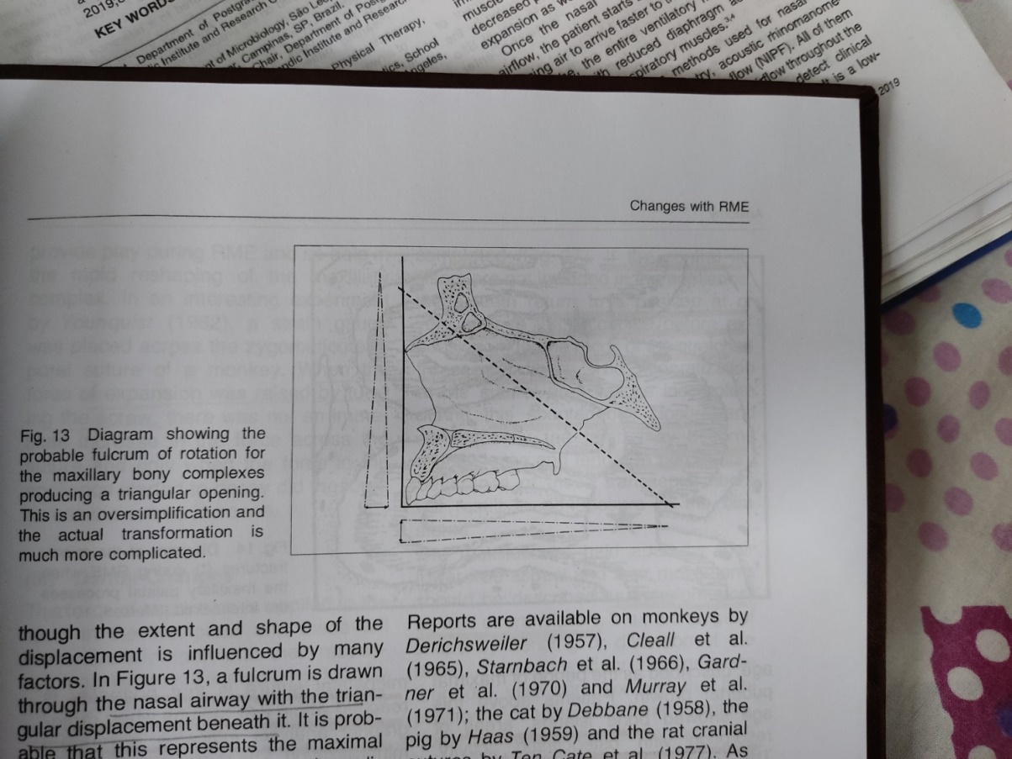

**Fig.7**Diagram showing the probable fulcrum of rotation for the maxillary bony complexes producing a triangular opening.

1. **Palatal Vault:**The palatine processes of the maxilla were lowered as a result of the outward tilting of the maxillary halves.30,31
2. **Alveolar Process**:Because bone is resilient, lateral bending of the alveolar process occurs early during rapid palatal expansion.17
3. **Arch Perimeter Changes:** Rapid palatal expansion with the Hyrax appliance produces increases in maxillary arch perimeter at the rate of approximately 0.7 times the change in first pre- molar width.17
4. **Maxillary Anterior Teeth:** From the patients point of view one of the most spectacular changes is the opening of a diastema between the maxillary central incisors. It is estimated that during active suture opening, the incisors separate approximately half the distance, the expansion screw has been opened.17
5. **Maxillary Posterior Teeth17:** With the initial alveolar bending and compression of the periodontal ligament there are definite changes in the long axis of the posterior teeth. Tipping of the teeth is seen which may be accompanied by some extrusion.17
6. **Mandible:** With RME there is a concomitant tendency for the mandible to swing downward and backward. The fairly consistent opening of the mandibular plane during RME is probably explained by the disruption of occlusion caused by extrusion and tipping of maxillary posterior teeth along with alveolar bending.17
7. **Mandibular Teeth**: Following RPE, the mandibular teeth have been observed to upright or to remain relatively stable.17
8. **Adjacent Facial Structures**: The craniofacial bones directly articulating with the maxilla are displaced except the sphenoid bone. The zygomatic arch acts as the main buttress against maxillary expansion.17
9. **Nasal airflow:** The nasal cavity width gain averages 1.9 mm, but can widen as much as 8 to 10 mm at the level of the inferior turbinates, while the more superior areas might move medially. Hershey, Stewart, and Warren and Turbyfill reported a reduction of nasal airway resistance by an average of 45% to 53% with RME.17

**CONCLUSION:**

In this review, brief idea of Rapid Maxillary Expansion(RME) were outlined so that it helps the clinician to correct absolute or relative maxillary-mandibular buccolingual discrepancies.

Therefore, we conclude with a quotation by founding father of RME E.C. Angell.32It comes from his second RME article, in which he made a spirited reply to an editorial criticism32, “For our mode of treating irregularities, we not only claim the separation of the maxillary bones, but we also assert without fear of contraindication, that this is a fact of the highest importance in this branch of dental surgery. More particularly that it renders the treatment of a large majority of cases hitherto complex, comparatively simple, while it saves an immense amount of time to the operator and an immense amount of suffering to the patient.”

**REFERENES:**

* 1. William R. Proffit, Henry W. Fields, Brent E. Larson, David M. Sarver .Contemporary Orthodontics. 6th Edition. Philadelphia: Elsevier Publication.
  2. Donald J. Timms. Rapid Maxillary Expansion. Quintessence Publishing Co.,Inc.2nd ed. Chicago; 1981.
  3. Suri L, Taneja P. Surgically assisted rapid palatal expansion: a literature review. American journal of orthodontics and dentofacialorthopedics. 2008 Feb 1;133(2):290-302.
  4. Dawson PE. New definition for relating occlusion to varying conditions of the temporomandibular joint. J Prosthet Dent 1995;74:619-27.
  5. Guichet NF. Biologic laws governing functions of muscles that move the mandible. Part I. Occlusal programming. J Prosthet Dent 1977;37:648-56.
  6. Jacobs JD, Bell WH, Williams CE, Kennedy JW 3rd. Control of the transverse dimension with surgery and orthodontics. Am J Orthod1980;77:284-306.
  7. Rakosi T, Jonas I, Graber TM. Color atlas of dental medicine: orthodontic diagnosis. New York: Thieme Medical Publishers; 1993.
  8. Redmond WR. Digital models: a new diagnostic tool. J ClinOrthod2001;35:386-7.
  9. Faber RD. Occlusograms in orthodontic treatment planning. J ClinOrthod1992;26:396-401.
  10. White LW. The clinical use of occlusograms. J ClinOrthod1982;16:92-103.
  11. Lehman JA Jr, Haas AJ, Haas DG. Surgical orthodontic correction of transverse maxillary deficiency: a simplified approach. PlastReconstSurg1984;73:62-8.
  12. Bell WH, Epker BN. Surgical-orthodontic expansion of the maxilla. Am J Orthod1976;70:517-28.
  13. Lines PA. Adult rapid maxillary expansion with corticotomy. Am J Orthod1975;67:44-56.
  14. Betts NJ, Vanarsdall RL, Barber HD, Higgins-Barber K, Fonseca RJ. Diagnosis and treatment of transverse maxillary deficiency. Int J Adult OrthodOrthognathSurg1995;10:75-96.
  15. Ricketts RM. Perspectives in the clinical application of cephalometrics. The first fifty years. Angle Orthod1981;51:115-50.
  16. Macchi A, Carrafiello G, Cacciafesta V, Norcini A. Threedimensional digital modeling and setup. Am J OrthodDentofacialOrthop2006;129:605-10.
  17. Bishara SE, Staley RN. Maxillary expansion: clinical implications. American journal of orthodontics and dentofacialorthopedics. 1987 Jan 1;91(1):3-14.
  18. John. L. Spoylar. The design, fabrication and use of a full coverage bonded rapid maxillary expansion appliance. Am J OrthodDentofacialOrthop 1984; 136-145.
  19. J.A. McNamara, Jr and W.L. Brudon. Orthodontic and Orthopedic treatment in the Mixed Dentition. Needham Press,1993.
  20. MacGinnis M, Chu H, Youssef G, Wu KW, Machado AW, Moon W. The effects of micro-implant assisted rapid palatal expansion (MARPE) on the nasomaxillary complex—a finite element method (FEM) analysis. Progress in orthodontics. 2014 Dec 1;15(1):52.
  21. Tausche E, Hansen L, Schneider M, Harzer W. Bone-supported rapid maxillary expansion with an implant-borne Hyrax screw: the Dresden Distractor. L'Orthodontiefrancaise. 2008 May 29;79(2):127-35.
  22. Wilmes B, Nienkemper M, Drescher D. Application and effectiveness of a mini-implant-and tooth-borne rapid palatal expansion device: the hybrid hyrax. World J Orthod. 2010 Jan 1;11(4):323-0.
  23. Isaacson RJ, Wood JL, Ingram AH. Forces produced by rapid maxillary expansion. Angle Orthod1964;34:256-70.
  24. Krebs A. Expansion of the midpalatal suture studied by means of metallic implants. EurOrthod Sot Rep 1958;34:163-71.
  25. Krebs AA. Expansion of mid palatal suture studied by means of metalicimplants. ActaOdontol Stand 1959; 17:491-501.
  26. Bell WH, Epker BN. Surgical-orthodontic expansion of the maxilla. Am J Orthod1976;70:517-28.
  27. Mew J. Relapse following maxillary expansion. A study of 25 consecutive cases. AM J ORTHOD 1983;33:56-61.
  28. Zimring JF, Isaacson RJ. Forces produced by rapid maxillary expansion. III. Forces present during retention. Angle Orthod1965;35:178-86.
  29. Timms DJ. A study of basal movement with rapid maxillary expansion. AM .I ORTHOD 1980;77:500-7.
  30. Haas AJ. The treatment of maxillary deficiency by opening the mid-palatal suture. Angle Orthod1965;35:200-17.
  31. Haas AJ. Rapid expansion of the maxillary dental arch and nasal cavity by opening the mid-palatal suture. Angle Orthod 1961; 31:73-90.
  32. Angel1 EC. Treatment of irregularities of the permanent or adult teeth. Dent Cosmos 1860;1:540-4.