**STEVENS JOHNSON SYNDROME : A CASE REPORT!!**

Case Report

Srishti1, Rajendra Gouda Patil2, Simi Thankappan3,Udita Singh4.

**Abstract:**

Stevens–Johnson syndrome is an acute, self-limited disease, presenting as severe mucosal erosions with widespread erythematous, cutaneous macules or atypical targets. Majority of cases are drug- induced, affecting oral & peri-oral region. Drugs are important cause of Stevens–Johnson syndrome (SJS) in about 95% of reports. We describe a case of SJS in a 20 year old male patient reported with a chief complaint of fever and extensive rashes on the skin of the face and neck, erythema of conjunctiva, ulceration in the oral cavity along with difficulty in routine oral habits. A yearlong follow-up revealed complete healing of the involved site with restoration of acceptable esthetics and no recurrence.

***Keyword****s*: Stevens–Johnson syndrome, Drug reaction.

**INTRODUCTION**

SJS was first described in 1922 by A.M. Stevens and F.C. Johnson in a report of two children with eruptive fever, stomatitis, and ophthalmia.1

“A new eruptive fever with stomatitis and opthalmia” was described as a severe variant of erythema multiforme & was termed by Steven and Johnson in 1922.2 It’s a life-threatening complications of drug therapy. 3 It is rare with an incidence of 0.05 to 2 persons per 1 million populations per year1. It is believed that drugs are the main cause of SJS (50 to 80% of cases)5. Infections or a combination of infections and drugs have also been reported as the etiology of the syndrome.6It is a severe hypersensitive reaction that can be precipitated by infection such as herpes simplex virus or mycoplasma, vaccination, systemic diseases, physical agents, foods and drugs.1The pathophysiological mechanism is not fully understood. It is believed to be a delayed hypersensitivity reaction mediated by Th1 cells.5They can affect patients of all ages and races but it occurs more in the male population.6

In 1993, a group of experts proposed a new classification in which SJS was separated from the EM spectrum and added to TEN, thereby creating a new spectrum of severe drug-related diseases. The criteria for diagnosis of SJS are epithelial detachment less than 10% of body surface area (BSA) and widespread erythematous or purpuric macules of flat atypical targets.7

The simplest classification breaks the disease down as follows:

• Stevens-Johnson syndrome: A minor form of toxic epidermal necrolysis, with less than 10% body surface area (BSA) detachment.

• Overlapping Stevens-Johnson syndrome/toxic epidermal necrolysis: Detachment of 10-30% of the BSA.

• Toxic epidermal necrolysis: Detachment of more than 30% of the BSA.8

They are potentially fatal, characterized by mucocutaneous tenderness, haemorrhagic erosions, erythema, blisters and areas of denuded skin. 3 There are no laboratory tests to point out the drug causing the disorder and, therefore, diagnosis is clinical.5

A 2016 summary and list of guidelines for management of SJS/TEN was published in the UK; it also confirms that, as yet, there is no active therapeutic regimen with unequivocal benefit.2

*1. Post Graduate Student, Department of oral medicine & radiology*

*2. Professor and Head, Department of oral medicine & radiology*

*3. Reader, Department of oral medicine & radiology*

*4.Senior lecturer,Department of oral medicine & radiology*

***\*Corresponding Address:***

*1. Dr. Srishti*

*Kothiwal Dental College & Research Centre, Moradabad, U.P.244001, India*

*Email: drsrishti1308@gmail.com*

**CASE REPORT**

A 20 year old male patient reported to oral medicine department with the complaints of ulcers in the mouth and rashes on the skin and face since 15 days.So 15 days back patient admit with the road traffic accident and discharge after 2-3 days, at that time he was put on some medication. Immediately after taking the medication patient develops rashes on all over the body and facewhich gradually increases to upper and lower extremities and genital area within two days. History of fever was also reported.neck, erythema of conjunctiva,

Patient had onset of multiple ulcers in his mouth associated with pain and bleeding, they were initially small in size, which gradually increased in number and size. Pain was sudden in onset, severe in intensity, continuous in nature and was of a lancinating type. Multiple blisters appeared which ruptured to form small ulcers over the lips which later became large. He had difficulty in swallowing solid and semi solid food.Medical history revealed that patient was given multiple drugs at the time of discharge, however patient didn’t have any medical history in the past. Personal and family history was non-significant.In his drugs history we found that he had been prescribed Tab. Vaepimo CP-5OO OD, Tab. Oflin 200 Mg BD, Cap Panfast DSR OD, Tab. Dolo 650mg QID for 5 days by a general practitioner, which he consumed for 3 days and developed this type of reaction.

On general examination patient was moderately built, poorly nourished, well oriented with time, space & things. He appeared toxic with generalized maculopapular rashes with erythema on the body. Vital signs were within the normal limits.

Extra oral examinationbilateral submandibular lymph nodes were palpable, tender and mobile. Extensive rashes on the skin surface, face, eye and genital area.

Ophthalmic examination showed acute conjunctivitis and subconjunctival hemorrhages. The hemorrhagic ulcerations of the eyelid was associated with watering of eyes.

Intra oral examination revealed multiple ulcerations on the labile and buccal mucosa, tongue, palate, upper and lower surface of the lips, extended from right oral commissures region to left oral commissures region also involving the vermilion border of the upper and lower lip with hemorrhagic crustation, erosions and active bleeding. The lips were swollen and cracked. Blood is covering the anterior part of upper and lower arch.

Based upon the history and clinical presentation a provisional diagnosis of Stevens–Johnson syndrome was made, however the other lesion were are considered as differential diagnosis like pemphigus vulgaris and erythema multiforme.Routine blood investigationsrevealed that the patient was anemic, raised ESR while the urine analysis revealed no abnormalities.

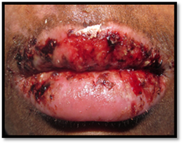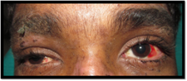

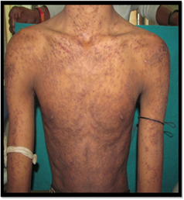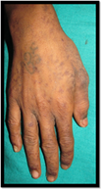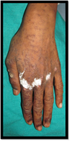

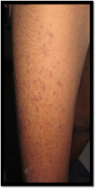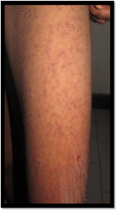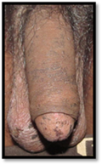

*Figure 1 showing lesions*

So the final diagnosis was confirmed as Stevens–Johnson syndrome and considering the seriousness of the patient’s condition immediately asked to stop the previous drugs.Following medications were subsequently administered : Systemic and topical corticosteroid along with antacid, vitamin, antiseptics and antioxidant mouthwash,Gylcerin (for topical application). The patient’s condition was reviewed on a daily basis and at the end of 10 days there was significant healing of the oral, cutaneous, eye and genitallesions. By the end of the third week, there was no evidence of cutaneous or mucosal ulcers. He is under continuous surveillance for the past 1 year and no signs of recurrence reported.

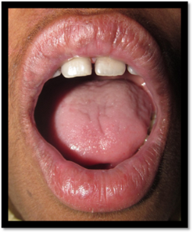

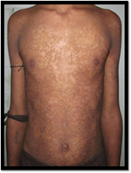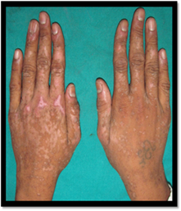

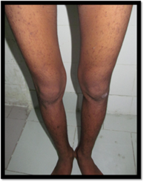

*Figure 2: showing post-opphotographs.*

**DISCUSSION**

SJS is a severe adverse drug reaction characterized by widespread lesions affecting the mouth, eyes, pharynx, larynx, esophagus, skin and genitals. It almost invariably involves the oral mucosa.7

It was described in 1922 two cases of patients with generalized skin rash, continuous fever, stomatitis and severe purulent conjunctivitis. In 1950, this clinical picture was divided into two categories: erythema multiforme minor (Von Hebra) and erythema multiforme major (EMM). As of 1983, the eponymous term Stevens- Johnson began to be used interchangeably with EMM.5In 2000 Bastuji-Garin et al. published a validated prognostic scoring system for SJS/TEN, called SCORTEN, which uses seven clinical parameters to predict probability of hospital mortality.8

The following investigations should be undertaken: 8

(i)full blood count, erythrocyte sedimentation rate, C-reactive protein, urea and electrolytes, magnesium, phosphate, bicarbonate, glucose, liver function tests, coagulation studies, and mycoplasma serology;

(ii) chest X-ray;

(iii) a biopsy from lesional skin, just adjacent to a blister, sent for routine histopathology, and a second biopsy taken from periblister lesional skin should be sent unfixed for direct immunofluorescence, to exclude an immunobullous disorder; swabs from lesional skin for bacteriology;

(iv) organize photographs of the skin to show type of lesion and extent of involvement.

Management of patients with SJS or TEN requires three measures: removal of the offending drug, particularly drugs known to be high-risk; supportive measures and active interventions.8

**CONCLUSION**

The case represents typical features of aSteven Johnson’s syndromestill there are many lesionswhich shows similarities with SJS so properhistory and clinical examination confirmed the diagnosis.Heteroatoms. Such drugs can cause photosensitivity reactions. However, treatment of SJS is nonspecific and is associated with sequelae.

**REFERENCES**

1. Deore1 SS, Dandekar RC, Mahajan AM, Shiledar VV. Drug Induced - Stevens Johnson Syndrome: A Case Report. Int J Sci Stud. 2014;2(4):84-87.
2. Jeremy A. Schneider, Philip R. Cohen. Stevens - Johnson syndrome and Toxic Epidermal Necrolysis: A Concise Review with a Comprehensive Summary of Therapeutic Interventions Emphasizing Supportive Measures. Adv Ther (2017) 34:1235–1244.
3. Saganuwan SA.Therapeutic Causes of Stevens – Johnson Syndrome - A Mini Review.Open Acc J of Toxicol.1(2);2017.
4. Wong A, Malvestiti AA, Hafner MFS. Stevens-Johnson syndrome and toxic epidermal necrolysis: a review. Rev Assoc Med Bras 2016; 62(5):468-473.
5. Babamahmoodi F, Eslami G, Babamahmoodi A. IJPT 11: 33-35, 2012
6. Shetty SR, Chatra L, Shenai P, Rao PK. Stevens-Johnson syndrome: a case report. J Oral Sci. vol. 52, No. 2, 343-346, 2010.
7. Anne S, Kosanam S, Prasanthi LN. Steven Johnson syndrome and toxic epidermal necrolysis: A review. IJPR vol.4(4);2014.
8. Creamer D, Walsh SA, Dziewulski P,Exton LS, Lee HY, Dart J.K.G, Setterfield J. U.K. guidelines for the management of Stevens–Johnson syndrome/toxic epidermal necrolysis in adults 2016. British Journal of Dermatology 174, pp1194–1227; 2016.
9. Letko E, Papaliodis DN, Papaliodis GN, Daoud YJ, Ahmed AR, Foster CS.Steven-Johnson syndrome and toxic epidermal necrolysis: A review of literature. Ann Allergy Asthma Immunol 2005; 94:419-36.
10. Stitt VJ. Stevens Johnson Syndrome: A review of the literature. JNMA 80(1); 1988.

How to cite this article: Shristi, Patil RG, Thankappan S,Singh U. Stevens Johnson Syndrome:-A Casereport. Chronicles of Dental Research 2017;Vol6(2)

How to cite this article: Kumari S, Roy R, Nair S, Kumar S. Unicystic Ameloblastoma in a 11- year old small child -A case report. Chronicles of Dental Research 2018; Vol 6(3): page no.

How to cite this article: Kumari S, Roy R , Nair S, Kumar S. Unicystic Ameloblastoma in a 11- year old small child -A case report. Chronicles of Dental Research 2018; Vol 6(3): page no.

How to cite this article: Kumari S, Roy R , Nair S, Kumar S. Unicystic Ameloblastoma in a 11- year old small child -A case report. Chronicles of Dental Research 2018; Vol 6(3): page no.

How to cite this article: Kumari S, Roy R , Nair S, Kumar S. Unicystic Ameloblastoma in a 11- year old small child -A case report. Chronicles of Dental Research 2018; Vol 6(3): page no.

How to cite this article: Kumari S, Roy R , Nair S, Kumar S. Unicystic Ameloblastoma in a 11- year old small child -A case report. Chronicles of Dental Research 2018; Vol 6(3): page no.