Case Report

**Case report**

**Management of Supernumerary teeth in the Maxillary anterior region- a case series**

Pooja Tiwari1, Chhaya Sharma1, Romana Nisar1, Sheeba Hassan1, Asma Jabin1

***ABSTRACT:*** Supernumerary teeth are the most common developmental dental anomalies in the maxillary anterior region causing interference to the developing permanent incisors resulting in oral problems such as malocclusion, food impaction, poor aesthetics, and cyst formation. Mesiodentes occur in 0.15% to 1.9% of the population. Mesiodens maybe present as a part of the symptoms of syndromes; however, this condition might be seen in normal individuals as well. Given this high frequency, the general dentist should be well informed about the signs and symptoms of mesiodentes and appropriate treatment. Extraction of mesiodens in the early mixed dentition helps spontaneous alignment of the adjacent teeth; however, symptomless cases could be left untreated along with regular check up. This article presents a case series of mesio dens and their treatment considerations.

**Keywords: Supernumerary teeth, mesiodense, management**

**INTRODUCTION**

Supernumerary teeth are defined as extra teeth compared to the normal dental series. They can be found in almost any region of the dental arch. Supernumerary teeth have more male predilection (ratio- 2:1). The prevalence of supernumerary teeth is 0.3%–0.8% in the deciduous dentition and 1.5%–3.5% in the permanent dentition. Mesiodens, the most commonly present supernumerary tooth is located in the maxillary central incisor

*1.Post Graduate Student.*

*Department of Pedodontics and Preventive Dentistry*.

**\**Correspondence Address:****Dr. Pooja Tiwari (P.G. Student) Kothiwal Dental College and Research Centre, Mora Mustaqeem Moradabad. Email:drpooja.312@gmail.com*region.

Mesiodens can occur individually or as multiples (mesiodentes), may appear unilaterally or bilaterally, and often do not erupt.

Mesiodentes can signiﬁcantly alter both occlusion and appearance by altering the eruption path and the position of the permanent incisors. Hence early detection and treatment assumes paramount importance.

This manuscript discusses five cases of mesiodens with their treatment plans.

CASE 1

A 7 year old male patient reported to the Department of Pedodontics and Preventive Dentistry, Kothiwal Dental College and Research Centre, Moradabad; with the chief complaint of pain in right upper back region of jaw. The patient reported spontaneous and intermittent pain in the same region which subsided on its own. The medical and the dental history of patient were non contributory. Extraorally, no abnormality was detected.

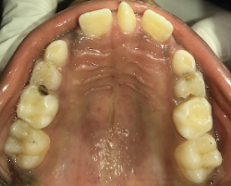

Fig 1(a) Fig 1(b)



Fig 1(c) Fig (e)



Fig (d)

The intraoral examination (Fig 1 a,b,c) revealed presence of conical tooth like structure in the maxillary anterior region and carious teeth irt 55, 64. On Radiographic examination (Fig 1 d), it was found that tooth like structure present between the upper centrals was mesiodense and also, there was another supernumerary tooth present mesial to the erupting left permanent canine which was still in the developing stage. It was decided to extract the mesiodense (Fig 1 e,f) and leave the other supernumerary tooth because it did not cause any disturbance in the eruption of canine. The midline diastema is expected to close on its own with the eruption of canine. The case is kept on follow up.

CASE 2-

A 17 year old male patient reported to theDepartment of Pedodontics and Preventive Dentistry, Kothiwal Dental College and Research Centre, Moradabad; with the chief complaint of misalignment of teeth and gap present between the upper teeth in the front region. The medical and the dental history of the patient was non contributory.

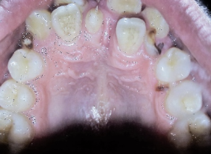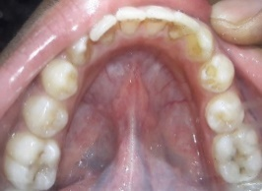

Fig 2 (a) Fig 2 (b)

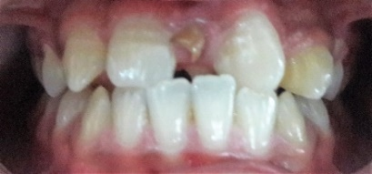

Fig 2 (c)

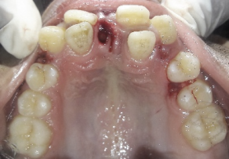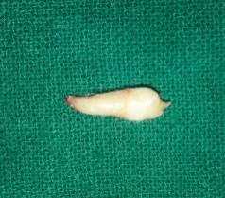

Fig 2 (d) Fig 2(e)

The intra oral examination (Fig 2 a,b,c) revealed crowding in the upper anterior region of jaw due to the presence of retained deciduous teeth in between 11 and 21. 12, 22 and conical tooth like structure were present palatally. Root stumps irt 53 and 63 was present. Radiographic examination revealed that the conical tooth like structure present palatally was supernumerary tooth and was diagnosed to be mesiodense. The extraction of the mesiodense along with the retained deciduous teeth was done (Fig 2 d,e) Orthodontic treatment was also planned to correct the alignment of the maxillary teeth.

The case is still on follow up.

CASE 3-

A 14-year-old male patient reported to the Department of Pedodontics and Preventive Dentistry, Kothiwal Dental College and Research Centre, Moradabad with the chief complaint of tooth present behind the upper front teeth. The medical and the dental history were non contributory. The intra oral examination (Fig 3 a,b) revealed palatally erupted supernumerary tooth irt 11,21 and mild crowding in both maxillary and mandible anterior region. The intraoral periapical radiograph (Fig 3 c) of the maxillary anterior region revealed palatally erupted mesiodense. The extraction of the mesiodense was done (Fig 3 d,e) and the patient was explained the orthodontic treatment as well. The patient did not report for the orthodontic treatment.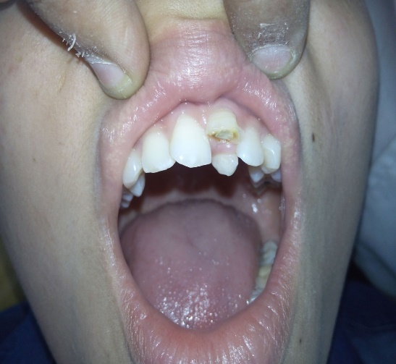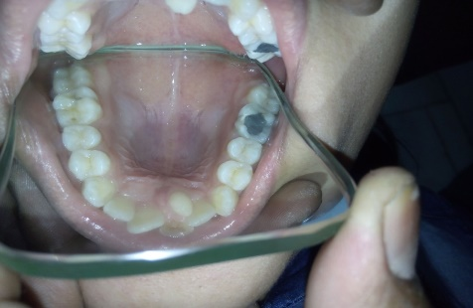

Fig 3 (a) Fig 3 (b)

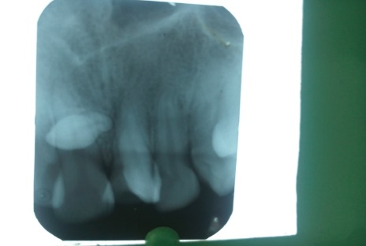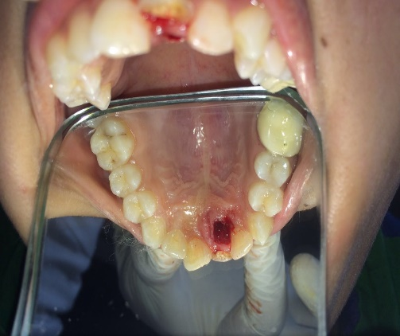

Fig 3 (c) Fig 3(d)

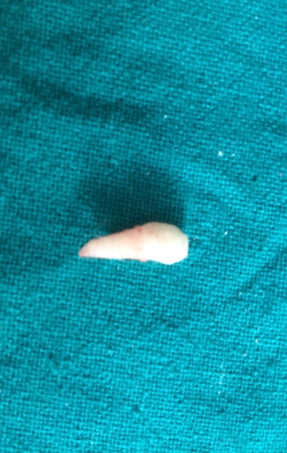

Fig 3(e)

CASE 4:

A 16 year old male patient reported to the Department of Pedodontics and Preventive Dentistry, Kothiwal Dental College and Research Centre, Moradabad with the chief complaint of misalignment of teeth in the upper front region of jaw. The medical and dental history were non contributory.

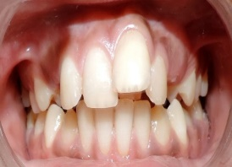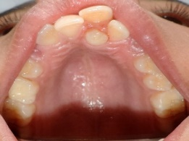

Fig 4 (a) Fig 4 (b)

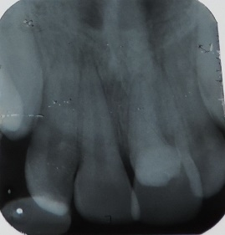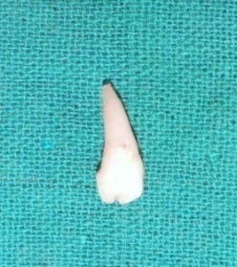

Fig 4(c) Fig 4 (d)

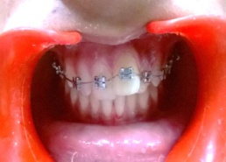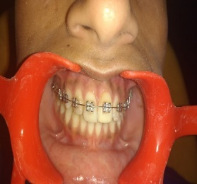

Fig 4 (e) Fig 4 (f)

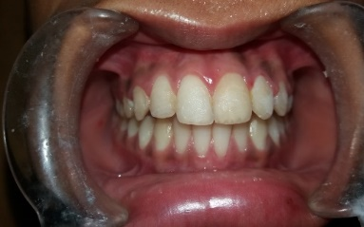

Fig 4 (g)

The intra oral examination revealed crowding in the maxillary anterior region along with the presence of tooth like conical structure present palatally. There was no abnormality detected in the mandibular arch. The intra oral periapical radiograph of the maxillary anterior region revealed the presence of supernumerary tooth palatally. Extraction of the mesiodense was done which was followed by fixed orthodontic treatment for 9 months. After debonding, a fixed retainer was given. The follow up after 1 year shows aligned maxillary teeth.

CASE 5-

A 7 year old male patient reported to the Department of Pedodontics and Preventive Dentistry, Kothiwal Dental College and Research Centre, Moradabad with the chief complaint of tooth like structure present behind the upper front teeth. The medical and dental history were non-contributory. The intra oral examination (Fig 5 a,b,c) revealed crowding in the maxillary anterior region along with the presence of tooth like conical structure present palatally and grossly carious irt 75, proximal caries irt 84 and occlusal caries irt 85. The intraoral periapical radiograph (Fig 5 d,e) revealed presence of supernumerary tooth in maxillary region and chronic irreversible pulpitis irt 75. The mesiodense was extracted on the same visit (Fig 5 f,g),and in subsequent appointments pulpectomy was done irt 75 (Fig 5 h,i)which was followed by stainless steel crown and 84, 85 were restored (Fig 5 j,k). The case is still on follow up and the patient has been advised fixed orthodontic treatment for crowding.

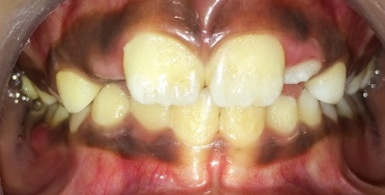

Fig 5 (a)

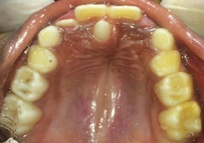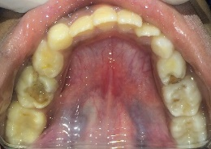

Fig 5 (b) Fig (c)

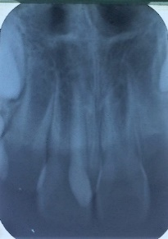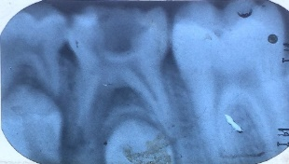

Fig 5 (d) Fig 5 (e)

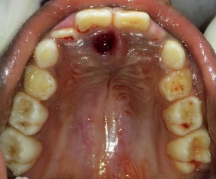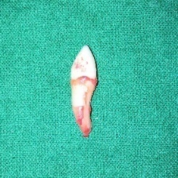

Fig 5 (f) Fig 5 (g)

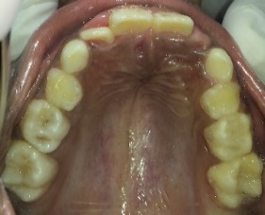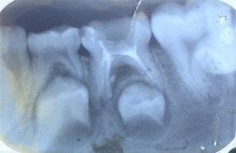

Fig 5 (h) Fig 5 (i)

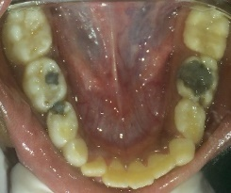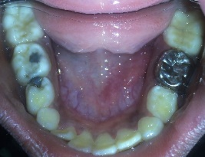

Fig 5 (j) Fig 5 (k)

DISCUSSION

Both genetic and environmental factors have been considered responsible for the occurance of supernumerary teeth. Various theories have been put forward-

1. Atavism theory- suggests that supernumerary teeth are a result of phylogenetic reversion to extinct primates with three pairs of incisors.2
2. Dichotomy theory- suggests that the tooth bud splits into two equal or different‑sized parts, resulting in the formation of two teeth of equal size, or one normal and one dysmorphic tooth respectively.4
3. Dental lamina hyperactivity theory- suggests localized, independent, conditioned hyperactivity of the dental lamina. According to this theory, a supplemental form would develop from the lingual extension of an accessory tooth bud, whereas a rudimentary form would develop from the proliferation of epithelial remnants of the dental lamina. This is the most accepted theory.2

They may also be associated with specific developmental syndromes, such as cleft lip and palate, cleidocranial dysplasia, chorhinophalangeal syndrome and Gardner’s syndrome.5

Morphologically, mesiodens may have heterogeneous forms. Three common types; namely, conical or peg shaped, tuberculate and supplemental (tooth like) have been reported, of which the conical form is the most common type.7,8

Supernumerary teeth may stay in their position for many years without any clinical interference to the dentition. They may erupt, stay impacted, appear inverted and assume an abnormal ectopic position. However, they most frequently cause local disturbances; such as delay or prevention in the eruption of the associated permanent incisors, midline diastema, crowding and mal alignment of the incisors, displacement and rotations of the adjacent teeth, possible development of dentigerous cyst, root resorption or dilaceration and migration into the nasal cavity or maxillary sinus. They may be detected by clinical examination as a result of delay in the normal eruption of the permanent incisor, or in a routine radiographic examination (panoramic or periapical) for pediatric dentistry or orthodontic examination and treatment planning. Therefore, early detection and timely intervention is imperative to avoid these deleterious effects in the maxillary anterior region.6

Delayed, ectopic or asymmetric eruption of the central incisors should alert the clinician to the possibility of a mesiodens. The clinician should obtain accurate radiographs. Early diagnosis of a mesiodens minimizes the treatment required and prevents development of associated problems.9 Only 25% of all mesiodentes spontaneously erupt into the oral cavity. If unerupted, the tooth can alter both the eruption of the permanent incisors and the resulting occlusion.Furthermore, in 75% of cases, the incisor erupts spontaneously once the mesiodens has been removed.10 Therefore, once a mesiodens has been diagnosed, the clinician must decide on treatment to minimize further sequelae.

Extraction of a mesiodens at a time appropriate for promoting self-eruption in the early mixed dentition may result in better alignment of the teeth and may minimize the need for orthodontic treatment.2

Supernumerary teeth can be either erupted or unerupted. Erupted supernumeraries should be preferentially extracted except in cases where the supernumerary teeth need to be retained. Unerupted teeth can be those associated with complications and those not associated with complications. Those not associated with complications can be kept under periodic review. Surgical removal can be delayed in cases if the supernumerary tooth is placed close to the apices of the developing permanent teeth or if the formation of the supernumerary teeth is in the initial stages resulting in chances of recurrence.

Clinician should consider patient condition in the final decision, however early removal of the supernumerary teeth in order to prevent complications is the treatment of choice.4

CONCLUSION

Mesiodense being the most common form of supernumerary teeth is not a rare condition. Extraction of mesiodense in early mixed dentition helps in preventing the malocclusion. However, symptomless cases could be left untreated with regular checkups.

REFERENCES

1. Di Biase DD. Midline supernumeraries and eruption of the maxillary central incisor. Dent Practit Dent Rec;20:35-40. 1969.
2. Primosch RE. Anterior supernumerary teeth — assessment and surgical intervention in children. Pediatr Dent 1981; 3(2):204–15.
3. Mason C, Azam N, Holt RD, Rule DC. A retrospective study of unerupted maxillary incisors associated with supernumerary teeth. Brit J Oral Maxillofac Surg 2000; 38:62-5.
4. Rajab LD, Hamdan MA. Supernumerary teeth: Review of the literature and a survey of 152 cases. Int J Paediatr Dent 2002;12:244‑54.

How to cite this article. Management of Supernumerary teeth in the Maxillary anterior region- a case series.Tiwari P,Sharma C, Nisar R, Hassan S, Jabin A Chronicles of Dental Research 2017 ;Vol6(2)

1. Brin I, Zilberman Y, Azaz B. The unerupted maxillary central incisor: review of its etiology and treatment. J Dent Child 1982. 49:352-6.
2. Howard RD. The unerupted incisor. A study of the post-operative eruption history of incisors delayed in their eruption by supernumerary teeth. Dent Pract 1976; 17:332-42.
3. Gallas MM, García A. Retention of permanent incisors by mesiodens: a family affair. Br Dent J 2000 ;188(2):63-4.
4. Prabhu NT, Rebecca J, Munshi AK. Mesiodens in the primary dentition--a case report. J Indian Soc Pedod Prev Dent 1998;16(3):93-5.
5. Von Arx T. Anterior maxillary supernumerary teeth: a clinical and radiographic study. Aust Dent J 1992; 37(3):189–95.
6. Hattab FN, Yassin OM, Rawashdeh MA. Supernumerary teeth: report of three cases and review of the literature. ASDC J Dent Child 1994; 61(5-6):382–93