Review article

**Root Canal Irrigants – A Paradigm Shift From Conventioal to Herbal Irrigation: A Review.**

Arun Singh Saharan1, Varun Arora2, Devendra Chaudhary3, Ravi Nagpal4, Atul Bishnoi5

**Abstract**

Irrigation is probably the most underrated procedure in Endodontic therapy. While most articles or presentations spend a great deal of time on shaping procedures, not much emphasis is given for irrigation. The use of chemical agents during instrumentation to completely clean all aspects of the root canal system is central to successful endodontic treatment. Irrigation iscomplementary to instrumentation in facilitating the removal of pulp tissue and/or microorganisms

**Keywords** – Root canal irrigant, Smear layer Sodium hypochlorite, Substantivity, Neem extract.

**INTRODUCTION**

The success of endodontic treatment depends on the eradication of microbes (if present) from the root-canal system and prevention of reinfection. The elimination of microorganisms from infected root canal systems is a complicated task involving the use of various instrumentation techniques, irrigation regimens and intracanal medicament.1

Whenever dentine is cut using hand or rotary instruments, the mineralized tissues are not shredded or cleaved but shattered to produce considerable quantities of debris. Much of this debris is made up of very small particles of mineralized collagen matrix, which is spread over the intracanal root dentinal surface to form what is called the

*1..Department of Conservative Dentistry and Endodonticst PG Student*

*2 Department of Periodontology & Oral Implantology PG Student*

*3.Department of Conservative Dentistry and Endodontics Professor & Head, Vice- Principal, Director P.G. Studies)*

*4.Department of Conservative Dentistry and Endodontics , Reader*

*5.Department of Conservative Dentistry and Endodontics , Senior Lecturer)*

*Address for Correspondence*

*Dr. Devendra Chaudhary. E mail: hellodrdc@gmail.com*

*Maharaja Ganga Singh Dental College & Research Centre, Sri Ganganagar (Rajasthan) India*

smear layer. The smear layer formed consists of fragments of the odontoblastic processes and necrotic debris. The smear layer may protect the bacteria within the dentinal tubules where it can penetrate upto a depth of approximately 40 microns and form a film of approximately 1-2 microns above the prepared dentine. Smear layer has the tendency to adhere to the root canal walls resulting into partial or complete occlusion of dentinal tubules and inappropriate sealing of the root canal system resulting into post operative leakage which would be eventually contributing to development or persistence of periapical inflammation.2, 3, 4

Although shaping of the root canal has been improved with advances in metal technology, cleaning of the canal still relies heavily on the adjunctive use of chemical rinsing solutions because of the various anatomical complexities and irregularities of the root canal system. Irrigation procedure thus becomes a very important step in the root canal therapy.5, 6

The irrigating process has three objectives as advocated by the Walker:

1) Dissolution of remnant tissue.

2) Antimicrobial.

3) Lubrication of the canal.7

It appears evident that root canal irrigants ideally should

(i) Have a broad antimicrobial spectrum and high efficacy against anaerobic and facultative microorganisms organized in biofilms,

(ii) Dissolve necrotic pulp tissue remnants,

(iii) Inactivate endotoxin,

(iv) Prevent the formation of a smear layer during instrumentation or dissolve the latter once it has formed,

(v) Be systemically nontoxic,

(vi) Be non caustic to periodontal tissues,

(vii) Have little potential to cause an anaphylactic reaction.8

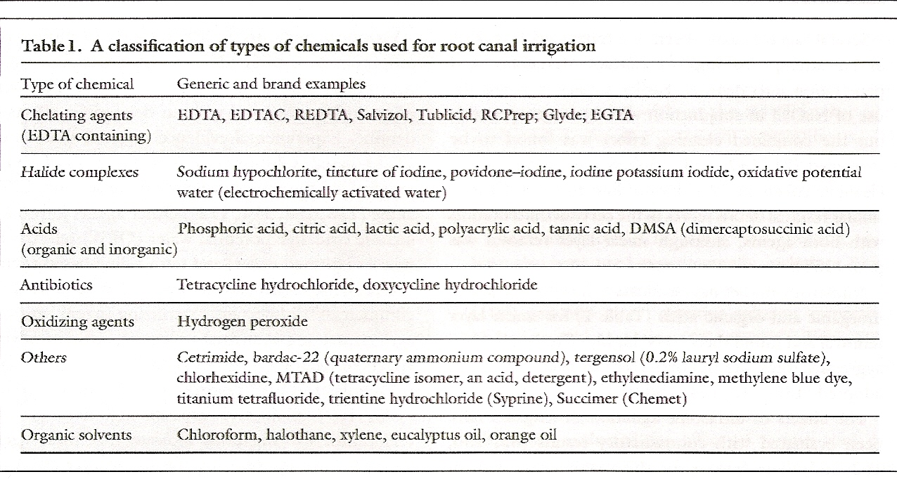

**Physiologic Saline:**

From a biological stand point, sterile normal saline is the best irrigant to use because it causes:

1) Least apical tissue irritation or damage.

2) Biocompatible.

3) Least amount of cell lysis.

Disadvantages:

1) However saline solution does not remove the smear layer but merely flushes out some of the superficial debris from the root canal system.

2) Has poor antibacterial properties, however irrigation followed by ultrasonic and sonic instrumentation have been reported to be almost as effective as 0.5 to 2.5% NaOCl irrigation in reducing the number of bacteria in infected root canals.

**Sodium Hypochlorite:**

Sodium hypochlorite (NaOCl) is the most popular irrigating solution 9. Hypochloric acid disrupts several vital functions of the microbial cell, resulting in cell death.10 It kills sessile endodontic pathogens organized in biofilms and in dentinal tubules efficiently. It also inactivates endodotoxins and disintegrates endodontic biofilms. It has the unique capacity to dissolve necrotic tissue and the organic components of the smear layer.11

There has been much controversy over the concentration of hypochlorite solutions to be used in endodontics. The antibacterial effectiveness and tissue dissolution capacity of aqueous hypochlorite is a function of its concentration, and so is its toxicity.12 Based on the currently available evidence, there is no rationale for using hypochlorite solutions at concentrations over 1%wt/vol. The most widely used irrigant for root canal therapy is NaOCl at a concentration of 0.5 to 5.25%.

The weaknesses of NaOCl include the unpleasant taste, toxicity, and its inability to remove the smear layer by itself, as it dissolves only organic material. The limited antimicrobial effectiveness of NaOCl in vivo is also disappointing. The poorer in vivo performance compared with in vitro is probably caused by problems in penetration to the most peripheral parts of the root-canal system such as fins, anastomoses, apical canal, lateral canals, and dentin canals.

**Hydrogen Peroxide:**

Hydrogen peroxide (H2O2) has been used as an endodontic irrigant for years, mainly in concentrations ranging between 3% and 5%. It is active against bacteria, viruses, and yeasts. The tissue-dissolving capacity of H2O2 is clearly lower than that of NaOCl.13 When used in combination with NaOCl, bubbling will occur as a result of nascent oxygen being released through the chemical reaction between these two liquids.

**EDTA (ethylene-diamine tetra-acetic acid) & CA (citric acid):**

On direct exposure for extended time, EDTA extracts bacterial surface proteins by combining with metal ions from the cell envelope, which can eventually lead to bacterial death.

EDTA is most commonly used as a 17% neutralized solution (disodium EDTA, pH 7), but a few reports have indicated that solutions with lower concentrations (eg, 10%, 5%, and even 1%) remove the smear layer equally well after NaOCl irrigation.

CA is also marketed and used in various concentrations, ranging from 1% to 50%, with a 10% solution being the most common. EDTA and CA are used for 2 to 3 minutes at the end of instrumentation and after NaOCl irrigation. Removal of the smear layer by EDTA or CA improves the antibacterial effect of locally used disinfecting agents in deeper layers of dentin.14

**Chlorhexidine (CHX):**

CHX permeates the microbial cell wall or outer membrane and attacks the bacterial cytoplasmic or inner membrane or the yeast plasma membrane. In high concentrations, CHX causes coagulation of intracellular components. One of the reasons for the popularity of CHX is its substantivity (ie, continued antimicrobial effect), because CHX binds to hard tissue and remains antimicrobial15

Despite its usefulness, chlorhexidine cannot be advocated as the main irrigant in standard endodontic cases, because

(a) Chlorhexidine is unable to dissolve necrotic tissue remnants

(b) Chlorhexidine is less effective on Gram-negative than on Gram-positive bacteria.

**MTAD (Mixture of Tetracycline, Citric Acid and Doxycycline hyclate):**

MTAD is a mixture of 3% doxycycline hyclate, 4.25% citric acid, and 0.5% polysorbate-80 (Tween 80) detergent. Commercially available as BioPure MTAD (DENTSPLY ), it is mixed as a liquid and powder prior to use. MTAD has been recommended in clinical practice as a final rinse after completion of conventional chemomechanical preparation.

In particular, MTAD mixture is effective against E. faecalis, and it is also less cytotoxic than a range of endodontic medicaments, including eugenol, hydrogen peroxide (3%), EDTA, and calcium hydroxide paste.16

**Tetraclean:**

Tetraclean (Ogna Laboratori Farmaceutici, Italy), like MTAD, is a mixture of an antibiotic, an acid, and a detergent. However, the concentration of the antibiotic, doxycycline (50mg/mL), and the type of detergent (polypropylene glycol) differ from those of MTAD.17

Treatment with Tetraclean caused a high degree of biofilm disaggregation at each time interval when compared with MTAD.

**Herbal irrigants:**

According to the World Health Organization (WHO), as many as 80% of the world’s people depend on traditional medicine (herbal) for their primary healthcare needs, although there may be regional variations.18

**1.Curcuma longaLinn. (Haridra *-* Turmeric):**

The active constituents of turmeric are the flavonoid curcumin (diferuloylmethane) and various volatile oils, including tumerone, atlantone, and zingiberone. Massaging the aching teeth with ground turmeric eliminates pain and swelling.19

**2.Carvacrol :**

Carvacrol is present in the oil of Origanum vulgare. Antibacterial effect of carvacrol and its isomer thymol against six ATCC standard bacterial strains including E. faecalis has been proved. Carvacrol also has anti‑inflammatory effects. It also helps in repair of periapical t

**3.Aloe Vera gel:**

Aloe leaves contain clear gel and green part of the leaf that surrounds the gel is used to produce juice or dried substance. Aloe Vera gel has inhibitory effects on S-pyogens and Efaecalis because of anthra quinine.21

**4.Morinda Citrifolia (noni):**

It is one of the first herbal alternatives given for an intra canal irrigant. In a study conducted by Prabhakar AR et al, Morinda Citrifolia was found to have significant anti bacterial activity which is attributed due to its contents alizarin, scopoletin, aucubin and asperuloside. However it was lower than 0.2% Chlorhexidine.

**5.Salvadora persica solution (Miswak):**

Its chewing sticks contain trimethyl amine, salvadorime chloride and fluoride in large amounts.It can be used as a substitute for sodium hypochlorite and chlorexidine as root canal irrigant.22

**6.Azadirachta indica (Neem):**

Neem’s anti viral, anti fungal anti bacterial and anti carcinogenic activity makes it a potential agent for root canal irrigation. Neem leaf extract is also used to treat dental plaque and gingivitis. Naiyak Arathi et al observed that ethanolic extract of neem had significant anti microbial activity against E.faecalis. It is an effective herbal alternative to the more commonly used irrigant sodium hypochlorite.23

**Conclusion**

Available literature and studies demonstrate

advantages and limitations of each irrigant under consideration and none of them satisfy the requirements of the ideal root canal irrigant completely. Presently the root canal irrigants could be used as an adjunct to each

other, with the hunt for the elusive ideal root canal irrigant continues.

**References:-**

1. Mohammadi Z, Abbott PV. The properties and applications of chlorhexidine in endodontics. International Endodontic Journal, 42, 288–302, 2009

2. Mader Cl, Baumgartner JC, Peters DD. Scanning electron microscopic investigation of the smear layer on the root canal walls. J Endod 1984; 10:477-83.

3. Akpata ES, Blechman H. Bacterial invasion of pulpal dentin wall in vitro. J Dent Res 1982;61:435-8,, Torabjinad M, Handysides R, Khademi AA, Bakland LK. Clinical implications of the smear layer in endodontics: a review. Oral Surg Oral MED Oral Pathol Oral Radiol Endod 2002;94:658-66

4. Shahravan A, Haghdoost AA, Adl A, Rahimi H, Shadifar F. Effect of smear layer on sealing ability of canal obturation: a systemic review and meta-analysis. J Endod 2007; 33:96-105.

5. Gutmann Jl. Problem solving in endodontics: prevention, identification and management. 5th ed. St Louis: Mosby; 2011.209.

6. Blanken J, De Moor RJG, Meire M, Verdaasdonk R. Laser induced explosive vapour and

cavitation resulting in effective irrigation of the root canal: part1- a visualization study. Lasers Surg Med 2009,41:514-9

7. Walker A. A definite and dependable therapy for pulpless teeth. J Am

Dent Assoc 1936;23:1418-26.

8. . M. Zehnder, “Root canal irrigants,” *Journal of Endodontics*, vol. 32, no. 5, pp. 389–398, 2006.

9. Mcdonnell G, Russell D. Antiseptics and disinfectants: activity, action, and resistance. Clin Microbiol Rev 1999;12:147–79.

10. McKenna SM, Davies KJA. The inhibition of bacterial growth by hypochlorous

acid. Biochem J 1988;254:685–92.

11. Spratt DA, Pratten J, Wilson M, et al. An in vitro evaluation of the antimicrobial efficacy of irrigants on biofilms of root canal isolates. Int Endod J 2001; 34:300–7.

12. M. Zehnder, “Root canal irrigants,” *Journal of Endodontics*, vol. 32, no. 5, pp. 389–398, 2006.

13. Schafer E. Irrigation of the root canal. *ENDO* 1:11–28, 2007.

14. Ørstavik D, Haapasalo M. Disinfection by endodontic irrigants and dressings of experimentally infected dentinal tubules. Endod Dent Traumatol 1990;6:142–9.

15. Mcdonnell G, Russell D. Antiseptics and disinfectants: activity, action, and resistance.

Clin Microbiol Rev 1999;12:147–79.

16. S. Shabahang, M. Pouresmail, and M. Torabinejad, “In vitro antimicrobial efficacy of MTAD and sodium hypochlorite,” Journal of Endodontics, vol. 29, no. 7, pp. 450–452, 2003.

17. L. Giardino, E. Ambu, C. Becce, L. Rimondini, and M. Morra, “Surface tension comparison of four common root canal irrigants and two new irrigants containing antibiotic,” Journal of Endodontics, vol. 32, no. 11, pp. 1091–1093, 2006.

18. P Principe. Monetising the pharmacological benefits of plants. US Environmental protection Agency, Washington, D.C 1991.

19. Chaturvedi TP. Uses of turmeric in dentistry in dentistry – an update. Indian J Dent Res 2009: 20(1): 107-109.

20. Nosrat A, Bolhari B, Sharifian MR, Aligholi M, Mortazavi MS. The effect of Carvacrol on Enterococcus faecalis as a final irrigant. Iran Endod J 2009;4:96‑100

21. Role of herbs in root canal irrigation-A review. Pratishta Jain, Manish Ranjan IOSR Journal of Pharmacy and Biological Sciences (IOSR-JPBS) Volume 9, Issue 2 Ver. VI (Mar-Apr. 2014), PP 06-10

22. Al- subawi NAK, Abdull- khalik K,Mahmud Y ,Taha MY, Abdul A. The Antimicrobial actitvity ion of Salvadora persica solution (Miswak –siwak) as root canal irrigant. University of sharjah journal of pure & applied science 2007:4: 69-91.

23. Hannah Rosaline, Kandaswamy D, Gogulnath D, Rubin MI, Influence of various herbal irrigants as a final rinse on the adherence of Enterococcus faecalis by fluorescence confocal laser scanning microscope, Journal of Conservative Dentistry, 16 (4), July-Aug 2013, 352-355.

How to site this article: Saharan AS, Arora V, Chowdhary D, Nagpal R, Bishnoi A.Root Canal Irrigants – A Paradigm Shift From Conventioal to Herbal Irrigation: A Review**.** Chronicals of Dental Research